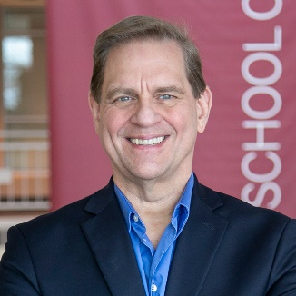
Dr. Keith is currently serving as Professor, Department of Curriculum and Instruction, Indiana University. His work focuses on preparing students for democratic civic participation, particularly through history and other social education content. His research examines students’ understanding of topics such as historical agency, historical significance, national identity, and human rights. He has collaborated with faculty, teachers, and students in countries including the United States, Northern Ireland, Singapore, New Zealand, Chile, South Sudan, Macedonia, and Sweden, among others. In addition to research with students, Dr. Keith’s work includes curriculum theory and practical classroom applications, especially through studies of exemplary teachers. He has also served as a Visiting Professor at the University of Ulster (Northern Ireland), Uppsala University (Sweden), Victoria University (New Zealand), and the National Institute of Education (Singapore). Additionally, he has been a Fulbright Senior Specialist in New Zealand.
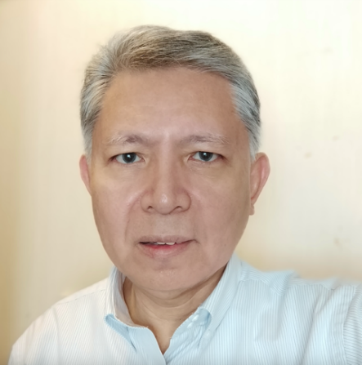
Jefferson R. Plantilla is a Researcher of the Asia-Pacific Human Rights Information Center (HURIGHTS OSAKA). He works on the regional (Asia-Pacific) program of HURIGHTS OSAKA which is mainly on human rights education. He researches on human rights education programs and activities in the Asia-Pacific, organizes international projects on developing teaching and learning materials, and publishes reports and books on human rights and human rights education. He edits Human Rights Education in Asia-Pacific (annual publication) and edited training materials (Business, Human Rights and Northeast Asia – A Facilitator’s Training Manual, Human Rights Lesson Plans for Southeast Asian Schools, Human Rights Education in the Northeast Asian School Systems - Resource Material, South Asian Teachers and Human Rights Education - A Training Resource Material). He attends as a resource person various human rights workshops and conferences organized by institutions in other countries in Asia since the late 1990s.



Yvonne Vissing, PhD, is a sociologist and children’s human rights expert. She is the founding director of the Center for Childhood & Youth Studies at Salem State University, where she is a Professor of Healthcare Studies. She is on the Human Rights Council for the American Association for the Advancement of Science in Washington and is on the Steering Committee of Human Rights Educators HRE USA. Vissing is the US Policy Chair for the UN Convention on the Rights Policy Center in Cyprus and is a member of the Universities Network for Children in Armed Conflict, a scholarly research and advocacy organization out of Italy. She is also a collaborator with the Observatory for the Human Rights of Children at the Hillary Rodham Clinton School of Law at Swansea University in Wales. Author of 23 books, including Children’s Human Rights in the USA: Challenges and Opportunities, Changing the Paradigm of Homelessness, Globalisation, Human rights and Education, Human Rights Around the Globe, Child Welfare in America, Globalisation, Human Rights, Sports, and Culture, Child and Youth Refugee Resettlement and Community Formation Issues, The Rights of Unaccompanied Minors, and research on the meaning of Santa Claus in multicultural contemporary societies.

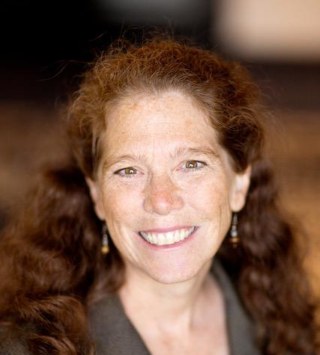
Kristi Rudelius-Palmer, Ph.D., is a human rights education consultant and the Human Rights Educators USA director and co-chair. Her recent projects have included a research study for UNESCO and the UN High Commissioner for Human Rights; a course and curriculum development for Amnesty International USA and the University of Iceland’s School of Education; and mentoring of Human Rights Watch high school student advisors to infuse human rights into their teaching. Kristi was selected as a Fulbright Specialist in 2023 and collaborated with faculty at the University of Iceland’s School of Education to design and co-instruct the first course on "Human rights: Advancing social and ecological wellbeing." She is a cofounder of Human Rights Educators USA and the University and College Consortium for Human Rights Education and serves on the executive committee of the Child Friendly Cities Initiative—Minneapolis-UNICEF. Kristi codirected the University of Minnesota Human Rights Center (1989–2016), including teaching as Adjunct Associate Professor of Law and directing the International Humphrey Fellowship Program (2003-2016).

In addition to teaching courses on human rights education, rule of law, and leadership at universities, primary and secondary schools, and community-education settings, Kristi presents at numerous international, national, regional, and local conferences. She also was publishing editor for This Is My Home: A Minnesota K–12 Human Rights Education Experience and the Human Rights Education Series of the Human Rights Resource Center (1997–2016). Kristi received the first Edward O’Brien Award for Human Rights Education from Human Rights Educators USA in 2015 and was awarded the University of Minnesota Outstanding Community Service Award in 2003. Kristi has collaborated with partners in more than 20 countries on human rights education initiatives. Kristi published her thesis on "Stories as Theories: Illuminating Human Rights Education Through the Narratives of Human Rights Educators."

Research interests:
Kristi’s research centers on the often-invisible voices and experiences of human rights activist educators, whose resilience and hope shape an alternative, equitable, collective narrative of history, evolution, and future of human rights education and training. The phenomenon she seeks to better understand is the conception of human rights education through personal lived experiences.
Kristi collaborates with human rights advocates, educators, and young people to create innovative programs and models of human rights teaching, dialogue, civic engagement, service learning, and reflection in classrooms and communities throughout Minnesota, the United States, and globally.

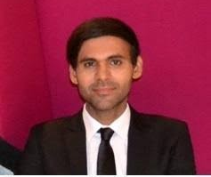
Munir is a human rights educator, social anthropologist, and socio-educational theorist. He holds a Ph.D. in Education with a concentration in HRE. He has been working as an Assistant Professor of Education for the last twelve years. He is also a founding volunteer director of the Global Forum for Teacher Educators, where he promotes complementary human rights education to children and women of marginalized communities.
Munir holds an esteemed international standing. He is the recipient of the Salem State University Honorary Fellowship, Global Heumann Fellowship, Charles Wallace Fellowship, Presidency of Turks and Related Communities (YTB) Research Fellowship, the Commonwealth UK, Distance Education Scholarship, and has served as a Visiting Academic Scholar at the Humboldt University of Berlin, and the University of California, Berkeley. He has also delivered guest lectures at global institutes including the School of Education, UC Berkeley, Adult School Berkeley and the Leuphana University of Lüneburg, Germany. He has developed a series of socio-eco-ethical models, including Munir's socioecoethical model of human rights education, socioecoethical model of social work, and socio-ethrical model of inclusivity, with global application in human rights education, social work, and inclusivity.

