Human Rights Education Curriculum Integration Guide Project

Lesson Plan Final, Revised Version: June 2021

LESSON TITLE: Digital Rights

RECOMMENDED GRADE LEVEL(S) FOR IMPLEMENTATION: High School

INSTRUCTIONAL TIME OR CLASS SESSIONS REQUIRED: (For fully online implementation, provide an approximate number of minutes) 2 hours 10 minutes

LESSON AUTHOR: Shabnam Mojtahedi and Karen Hopkins

AUTHOR AFFILIATION: (SCHOOL OR OTHER INSTITUTION): HRE USA

BRIEF DESCRIPTIVE SUMMARY OF LESSON: (SHOULD NOT BE A RESTATEMENT OF LEARNING GOALS—LIMIT SUMMARY TO 3 SENTENCES.)

The digital world has become a seamless extension of our day-to-day reality, and as a result, we access information, make connections, and buy goods online without distinguishing between online and offline spaces. But our understanding of the laws, rights, and responsibilities when we access and use the Internet have lagged behind the extreme pace of technological development. In this lesson, students will learn about the rights you have every time you use a digital device to post, communicate, click, and browse as well as the rights that young people and digital advocates are demanding be enacted into law in the United States. You will also learn about your responsibilities as users of the Internet regarding the way you consume and share information and engage with others in online spaces. When we better understand our digital rights, we are empowered to be good digital citizens and insist that companies and the government develop technology in ethical and responsible ways.

NJ STUDENT LEARNING STANDARDS ADDRESSED IN LESSON:
(CITE BOTH THE STANDARD AND THE RELEVANT PERFORMANCE INDICATOR/S)
https://www.nj.gov/education/cccs/2020/2020%20NJSLS-SS.pdf

- 6.1.12.CivicsPD.16.a: Construct a claim to describe how media and technology has impacted civic participation and deliberation.
- 6.1.12.CivicsPR.16.a: Analyze government efforts to address intellectual property rights, personal privacy, and other ethical issues in science, medicine, and business that arise from the global use of new technologies.
- 6.3.8.CivicsPR.3: Take a position on an issue in which fundamental ideals and principles are in conflict (e.g., liberty, equality).
- 6.1.12.EconNE.16.b: Evaluate the economic, political, and social impact of new and emerging technologies on individuals and nations.

COMMON CORE CURRICULUM STANDARDS REFERENCED IN LESSON:

- CCSS.ELA-LITERACY.RH.6-8.8 Distinguish among fact, opinion, and reasoned judgment in a text.
- CCSS.ELA-LITERACY.RST.6-8.8 Distinguish among facts, reasoned judgment based on research findings, and speculation in a text.
- CCSS.ELA-LITERACY.RST.6-8.9 Compare and contrast the information gained from experiments, simulations, video, or multimedia sources with that gained from reading a text on the same topic.

LITERACY DEVELOPMENT CONNECTIONS IN LESSON:

A. Completion and comprehension of lesson readings.

B. Development and presentation of arguments about lesson materials.

LESSON GOALS/OBJECTIVES: Students will be able to:

1. Identify predominant rights and responsibilities related to the use of the Internet and digital platforms.

2. Recognize the ways in which students’ personal experiences, current events, and public discourse about technologies intersect with theories on digital rights.

3. Explain the tension between different digital rights, such as between free expression and the right to privacy.

LESSON METHODOLOGY AND PROCEDURES:

(5 min) Introduce the concept of digital rights
- Ask the following prompting questions to spark dialogue, intrigue students and get them thinking critically.
  - “How many of you have email? How many of you have read the terms of service for your email account?”
    - Interactive exercise: can use 2-3 of these questions about the Google terms of service OR have students take the whole quiz.
  - “What you post today could have repercussions two, three or even ten years from now. Data over time can be aggregated and new artificial intelligence technologies can connect the dots and reveal a lot about you as a person.”
- Explain the plan for the lesson. “First, we will define our digital rights and responsibilities and how they link to human rights. Then, we will do an exercise to dive deeper into how technology can be abused in a systematic way.”

(45 min) Discussion and Mapping of Digital Rights/Responsibilities
- Start with a quick timeline of technological development using the “Brief History of the Internet” handouts and infographics (Refer to Handout 1 by providing copies or sharing on the screen: History of the Internet. For digital lessons, teachers could also put handouts in a PowerPoint and distribute for students so that screen sharing is not necessary.)
  - 1946 The very first computer is invented.
  - 1948 Post-World War II world leaders developed a list of basic rights applicable to all human beings in the form of a treaty called the Universal Declaration of Human Rights, which was adopted 73 years ago.
  - 1974 The first personal computer was developed.
  - 1989 The Internet is invented.
  - 2004 Mark Zuckerberg released "The Facebook."
  - 2007 Smartphones come out.
  - 2017 Artificial Intelligence or machine learning was developed.
  - Today The pace of change since then has been faster than ever before, and our laws and the ways we apply human rights protections to the digital sphere has not caught up!
- What are digital rights? What human rights are applicable in the digital sphere, on the Internet?
  - There are three categories of rights related to the Internet:
    - Briefly review the list of rights in the UDHR handout and discuss the questions below. These rights are applicable whether you are online or offline. This portion of the activity can be modified for time or for a deeper dive into the concept by focusing only on the overlap of rights.
    - Q1-What rights do we all have in the United States based on the Bill of Rights? (See U.S. Bill of Rights)
      - First Amendment Rights: freedom of speech, privacy, freedom of assembly
      - Fourth Amendment Rights: freedom from unreasonable search and seizure (data, surveillance)
      - Ninth Amendment: access to one right doesn’t deny access to other rights
      - Fourteenth Amendment: right to life, liberty, and property + equal protection under the law
    - Q2-Which human rights do you think overlap with digital rights and why? For example, if you have the right to an education, and education is online, then you have a right to be able to access online education -- what do you need to be able to do that? (Answer: wi-fi connection, a digital communication device, material that can be accessed by students with different abilities).
    - There are some concepts that have been developed to make fundamental rights more applicable to the digital age. These are contemporary extensions of existing rights, such as freedom of expression, that have been adapted for online users:
      - The right to control data gathered about you online including how it is collected, used or shared, and the right to remove data.
      - The right to knowledge and informed consent about how your data is being used
      - The right to digital literacy: the skills and knowledge to utilize and access communication and information technologies, such as the internet, cell phones, and social media.
- With rights we also have responsibilities to respect those rights and consider the impact on others. Ask students in small groups of three to four to chart or diagram how our own digital rights are connected to the rights (digital or non-digital rights) of others by using the following two prompts. This activity can be modified for time by only using one of the prompts (see lesson resource handouts), having some small groups do the Venn diagram and others do the flowchart, or by doing the prompt(s) collectively as a class. Examples of these types of diagrams are included in the handouts section.
  - Create a Venn Diagram showing your digital responsibilities to yourself and to others and how these may overlap.
  - Create a Flowchart showing how our failures to protect our own digital rights have a ripple effect on others and vice versa.
  - If done in small groups, each group should compare with another group. If some groups are doing Venn Diagrams and others are doing flowcharts, these groups could swap and share their findings. Ideally, groups should post or display (physically or virtually if your class online platform allows) so that everyone can compare all the diagrams and/or charts.
(75 minutes) Systemic Abuses of Digital Rights
- Watch video clip below introducing systemic abuse of technology (5 min) Amnesty report: Are Google and Facebook a threat to human rights?
- Small Group Discussion: Technology has been used to advance society in many good ways, however it has also been systematically abused by corporations and governments to infringe upon the rights of individuals and communities. Technology is developing much more quickly than laws to protect rights related to those technologies can be developed. This leaves gaps in the law and can have implications that can make individual rights vulnerable. Recent examples of this include tracking software used in phones as well as facial recognition and race detection software used by law enforcement.
    - Break the class into small groups, at least four if possible. If you are unable to easily break into groups, students can choose one of the topics below or the whole class can focus on one topic. If time is an issue this activity can be modified by reducing the number of articles to review. If necessary, poll the class to determine which 1-2 articles interest them most and focus on those. This will cut the activity time by 20-30 minutes.
    - (20 min) Each group will read excerpts from a different article, take notes and prepare to share highlights with the rest of the class. Each group will assign a note taker and a speaker. Provide Handout #3 to the students or include in a PowerPoint slide for reference. This handout provides structure for the notetaking and sharing investigation.
      - Valentino-DeVries, J. “How the Police Use Facial Recognition, and Where it Falls Short,” NY Times. 2020.
      - Hinduja, Sameer and Justin Patchin. “Cyberbullying: Identification, Prevention and Response Fact Sheet” Cyberbullying Research Center. 2020.
      - Thompson, Stuart A. and Charlie Warze. “Twelve Million Phones, One Data Set, Zero Privacy,” NY Times. December 19, 2019.
      - Olson, Parmy. “The Quiet Growth of Race Detection Software Sparks Concerns Over Bias,” Wall Street Journal. August 14, 2020.
    - (40 min/10 min per group) Each group will take notes on the important facts from the article, using information from their article to answer these questions from Handout #3 and then share their findings with the class.
      - What’s the issue the technology was developed to address?
      - What’s the problem with how the technology is being used?
      - Highlights - main take away from the article?
      - How could one prevent or address the problem posed in the article?
- Take Action/Experiential Learning (10 min) - How to protect your data and your privacy
  - Watch the seven minute video by Above the Noise. “5 Tips to Protect Your Privacy Online,” YouTube. November 17, 2015.
  - Provide students with Handout #4 which explains how students can opt out of ad personalization on various platforms should they choose to do so.
  - Provide students with Handout #5 which explains how students can update location and tracking settings on their phones should they choose to do so.

(5 minutes) Class summary and closing

- The instructor should recap that the UDHR includes 30 rights, many of which are intertwined with digital rights.
- Ask students to briefly define “human rights for a digital age.” (Example: The rights that enable individuals and communities to access and utilize technology, specifically the internet and mobile networks.)
- Ask 1-2 students to briefly recap the digital responsibilities discussed earlier in the lesson and ways students identified that individuals and institutions respect and protect rights.
- The instructor should explain that the pace of technological advancement is so quick that laws often don’t address new tensions between rights. As a result, some rights are abused, often on a massive scale.
- The difficult task now is in finding ways to balance and protect these rights. Prompt students to provide examples of some of the things we can do individually or collectively to protect these rights. (Example: updating cell phone, social media, and app privacy settings.)

ASSESSMENTS OF STUDENT PERFORMANCE:

- Is the student able to identify 2-3 rights and responsibilities they have with regard to digital platforms? Assess this skill based on class discussions on rights and responsibilities and/or ask students to write two sentences for each explaining one digital right and the responsibility that comes along with that right. See sample rubrics for assessment of written work and participation in class discussion. These generic rubrics should be modified to reflect the specific content focus of this lesson.
- Is the student able to clearly articulate how their personal experience with a technology platform intersects with a current event/discourse on digital rights? (Example: location tracking, online purchases and advertising) Assess this skill based on class discussions and chart/diagram activity analysis or have each student write a reflection paragraph using the question above and then swap with a partner and compare experiences. See sample rubrics for assessment of written work and participation in class discussion.
- Is the student able to explain the tension between two digital rights and suggest ways to resolve such tension? Assess this skill using written responses for Handout #3. See sample rubrics for assessment of written work.

LEARNING RESOURCES: (THOSE USED IN THIS LESSON—GIVE FULL CITATIONS AND/OR ELECTRONIC LINKS TO CONTENT/MATERIALS). IF YOU USE ITEMS YOU PREPARED, SUCH AS WORKSHEETS OR OTHER TEACHER DESIGNED MATERIALS, INCLUDE THEM WITH THIS LESSON PLAN AS WORD FILES.

- Complete the Interactive Google Terms of Service Quiz individually, in small groups or as a class. Ossola, Alexandra. “How much do you know about the personal data you give up online?” Quartz. November 26, 2018.
- Brief history of the internet
  - Campbell, Dug. “A History of the Internet” Infographic, November 30, 2018.
  - Catalina, Juana. “A Brief History of How Internet of Things Become a Thing” Timeline Infographic, SlideShare. June 26, 2018.
- Flowers, Nancy. “Human Rights Here and Now Appendix 5: The Universal Declaration of Human Rights (Abbreviated),” Amnesty International. (1999.)
- Venn Diagram and Flowchart Templates (provided with lesson)
- DW News. “Amnesty report: Are Google and Facebook a threat to human rights?” November 23, 2019.
- Valentino-DeVries, J. “How the Police Use Facial Recognition, and Where it Falls Short,” NY Times. 2020.
- Hinduja, Sameer and Justin Patchin. “Cyberbullying: Identification, Prevention and Response Fact Sheet” Cyberbullying Research Center. 2020.
- Thompson, Stuart A. and Charlie Warze. “Twelve Million Phones, One Data Set, Zero Privacy,” NY Times. December 19, 2019.
- Olson, Parmy. “The Quiet Growth of Race Detection Software Sparks Concerns Over Bias,” Wall Street Journal. August 14, 2020.
- Wamsley, Laurel. “Your Technology is Tracking You. Take these Steps for Better Privacy Online.” NPR. October 13, 2020.
- Gould, Cynthia. “How to Stop Cell Phone Apps from Tracking You and Selling your Information,” ABC News. July 13, 2020.
- Sample rubrics for assessment of written work and participation in class discussion include the rubric for "Online Discussion Boards" from Northwestern University's Searle Center for Advancing Learning & Teaching and the "Grading Rubric for Written Assignments" from Southern Nazarene University.

EXTENSION RESOURCES: (RESOURCES WHICH FACULTY AND STUDENTS CAN USE TO FURTHER EXPLORE OR EXTEND LEARNING ABOUT THE LESSON TOPICS)

- Watch a 2 minute video by UN Human Rights. “Human rights in the digital age,” YouTube. Posted November 21, 2018.
- Additional discussion prompts related to balancing digital rights
  - Has technology improved our ability to access rights and infringed upon our rights? For instance, access to information is hypothetically a universal right in the internet age, however the reality is that it is not truly universal due to costs associated with access and lack of infrastructure in some places.
  - What costs are associated with increased access to information? How do individuals and governments decide where the risk of rights infringement is worth the benefit of the technology?
  - What are the tensions between the right to privacy and freedom of expression?
- Misinformation: how to discern what’s true and what’s not true in digital content
  - How to know whether a source is reliable
    - Conduct a Google search on a controversial news topic
    - Find two articles that have opposing views on the issue
    - Use this NPR article to analyze the source and content of both articles. Davis, Wyne. “Fake News or Real? How to Self-Check the News and Get the Facts,” NPR. December 5, 2016.
  - Fact Checking vs. Free Speech on YouTube, Facebook and Twitter. See - Zakrzewski, Cat. “The Technology 202: Trump will face new rules on Facebook and Twitter after he leaves office,” Washington Post. November 13, 2020.
  - How social media has changed the way we consume news. The rise of “fake news” and the increase in reliance on the internet and social media as opposed to TV or newspapers for news. See - Skenderian, Ashley. “News at your fingertips,” Medium. September 30, 2019.
  - When consuming information online, what are you sharing back out?
- Research law and rules related to digital rights and privacy in your state/city. Compare laws in your state to similar laws in other countries and states using
  - The Privacy Project. “Opinion - Why is America So Far Behind Europe on Digital Privacy?” NY Times. June 8, 2019.
  - McCoy, Owen. “A Legislative Comparison: US vs. EU on Data Privacy,” European Interactive Digital Advertising Alliance.
- Review the Cities for Digital Rights "Declaration of Cities for Digital Rights" and the cities that have adopted it. Review the Cities for Digital Rights "Checklist." Write to your local leadership to ask that they sign onto the Declaration and implement measures from the checklist.
- Lee, Timothy. “Net Neutrality, Explained.” Vox. Updated May 21, 2015.
- “What’s the Worst That Could Happen With My Phone Data? Our Journalists Answer Your Questions,” NY Times. Published Dec. 26, 2019. Updated Aug. 19, 2020.
- Resources for Educators from the Cyberbullying Research Center on Cyberbullying and LGBTQ Students, Sexting, Digital Dating Abuse

MODIFICATIONS OR ADAPTATIONS OF THE LESSON FOR DIFFERENTIATED LEARNERS: (CLASSIFIED STUDENTS, ENGLISH LANGUAGE LEARNERS, OTHERS)

- Adaptations to the lesson can be made by allowing several class periods to complete the article activities so that all article topics are covered, for example, or allowing students to select one article to discuss, rather than all four.
- Groups could be paired heterogeneously by achievement levels to scaffold each other and provide additional support for struggling readers. Depending on class size and skill level students could be divided into larger or smaller groups.
- An illustrated version of the Universal Declaration of Human Rights (UDHR) is available at: https://www.un.org/en/udhrbook/. The UDHR can be accessed in other languages at: https://www.un.org/en/about-us/universal-declaration-of-human-rights (click on tabs at top right corner of the website).
- A version of the U.S. Bill of Rights in simpler language is available from the ACLU – Delaware (https://www.aclu-de.org/en/know-your-rights/bill-rights-simple-language)
- The YouTube video from DW on the Amnesty report can be played with Closed Captioning on.
- For the articles to be read, they can be printed out for ELL students and vocabulary scaffolding sheets can be developed to assist them with unfamiliar language and technical terms.

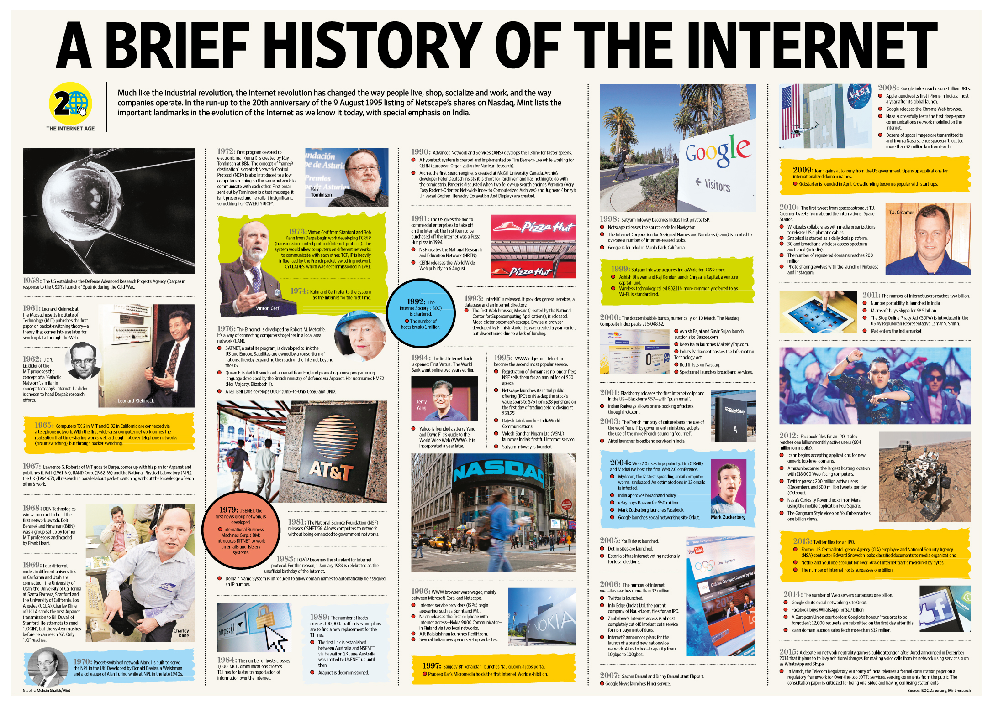Campbell, Dug. “A History of the Internet” Infographic, November 30, 2018.

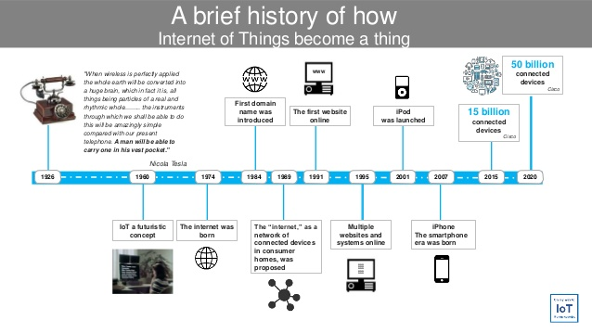Catalina, Juana. “A Brief History of How Internet of Things Become a Thing” Timeline Infographic, SlideShare. June 26, 2018.

The Universal Declaration of Human Rights (abbreviated)
Article 1 | Right to Equality
Article 2 | Freedom from Discrimination
Article 3 | Right to Life, Liberty, Personal Security
Article 4 | Freedom from Slavery
Article 5 | Freedom from Torture and Degrading Treatment
Article 6 | Right to Recognition as a Person before the Law
Article 7 | Right to Equality before the Law
Article 8 | Right to Remedy by Competent Tribunal
Article 9 | Freedom from Arbitrary Arrest and Exile
Article 10 | Right to Fair Public Hearing
Article 11 | Right to be Considered Innocent until Proven Guilty
Article 12 | Freedom from Interference with Privacy, Family, Home and Correspondence
Article 13 | Right to Free Movement in and out of the Country
Article 14 | Right to Asylum in other Countries from Persecution
Article 15 | Right to a Nationality and the Freedom to Change It
Article 16 | Right to Marriage and Family
Article 17 | Right to Own Property
Article 18 | Freedom of Belief and Religion
Article 19 | Freedom of Opinion and Information
Article 20 | Right of Peaceful Assembly and Association
Article 21 | Right to Participate in Government and in Free Elections
Article 22 | Right to Social Security
Article 23 | Right to Desirable Work and to Join Trade Unions
Article 24 | Right to Rest and Leisure
Article 25 | Right to Adequate Living Standard
Article 26 | Right to Education
Article 27 | Right to Participate in the Cultural Life of Community
Article 28 | Right to a Social Order that Articulates this Document
Article 29 | Community Duties Essential to Free and Full Development
Article 30 | Freedom from State or Personal Interference in the above Rights

Flowers, Nancy. “Human Rights Here and Now Appendix 5: The Universal Declaration of Human Rights (Abbreviated),” Amnesty International. (1999.)

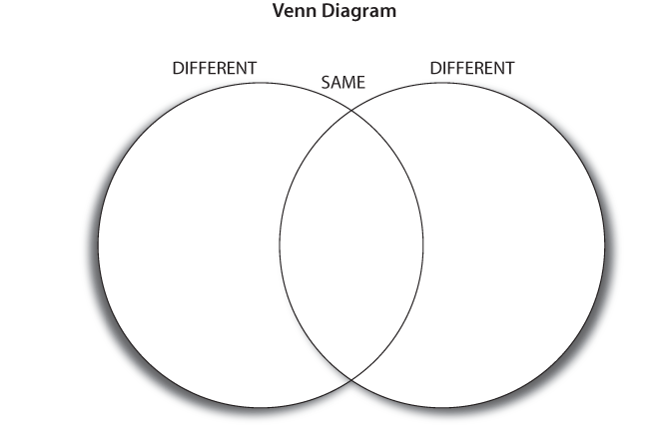
Flow Chart Example
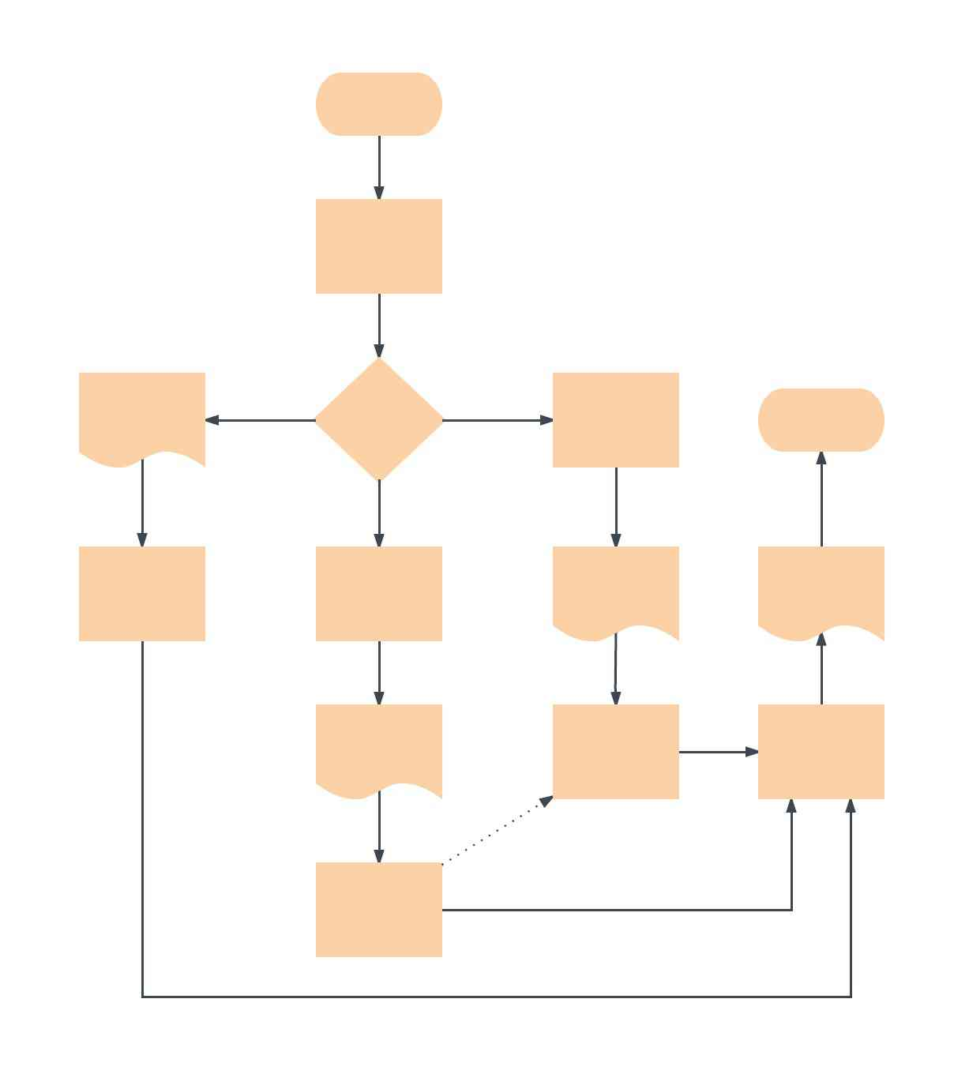
Handout #3 Group Discussion
What’s the issue/problem the technology was developed to address? |  | Notes from the Article:
List a few of the links between the problem addressed in the article and human rights. |  | Notes from the Article:
What’s the problem with how the technology is actually being used? |  | Notes from the Article:
Explain 1-2 of the articles main takeaways in your own words |  | Notes from the Article:
Suggest some ways the problem raised in the article could be prevented or addressed. |  | Notes from the Article:

Handout #4: Opting Out Of Ad Personalization On Some Major Platforms
- Google and Android Here's a link to limit ad personalization on Google and Android.
- Apple This page shows you how to opt out of ad personalization on Apple. As of this writing, it hasn't been updated for iOS 14. If you have updated to iOS 14, go to Settings > Privacy > Apple Advertising > turn off Personalized Ads.
- Facebook
- On this page, you can go to the ad settings tab and toggle the settings to not allowed.
- This page has steps to disconnect your activity off Facebook that is shared with Facebook, and clear that history.
- On the Off-Facebook activity page, under What You Can Do, you can click on More Options > Manage Future Activity > and toggle it to off. (This page has those steps.)
- Twitter This page explains how to opt out of ad personalization.
- Go to myactivity.google.com and delete everything you can. On the left, there's a tab that says "Delete activity by." Select "All time." On your My Google Activity page, you can turn off Web & App Activity, Location History and YouTube History. "It will show you every search term and everything you've ever done, every YouTube video you've ever looked at, all that stuff," he says. "It'll say, are you sure you want to delete this? 'Cause if you delete this, it might affect some stuff." Mitchell says: Delete it.
Wamsley, Laurel. “Your Technology is Tracking You. Take these Steps for Better Privacy Online.” NPR. October 13, 2020.
Handout #5 STEPS TO LIMIT LOCATION TRACKING

Apple:

Go to Settings > Privacy > Location Services, and either turn off the global Location Services switch or turn off the individual location switch of each location-aware app or feature by setting it to “Never”.

To disable Location Services for all websites, set the Location Services setting for Safari to “Never”.

You can also disable location-based system services by tapping on System Services and turning off each location-based system service.

Android:
- Turn location on or off for your phone
- Swipe down from the top of the screen.
- Touch and hold Location Location. If you don't find Location Location:
- Tap Edit Edit or Settings Settings.
- Drag Location Location into your Quick Settings.
Golden Rule: Turn Off your phone or turn off GPS, WiFi, and Bluetooth when you don’t need to use them.

Gould, Cynthia. “How to Stop Cell Phone Apps from Tracking You and Selling your Information,” ABC News. July 13, 2020.

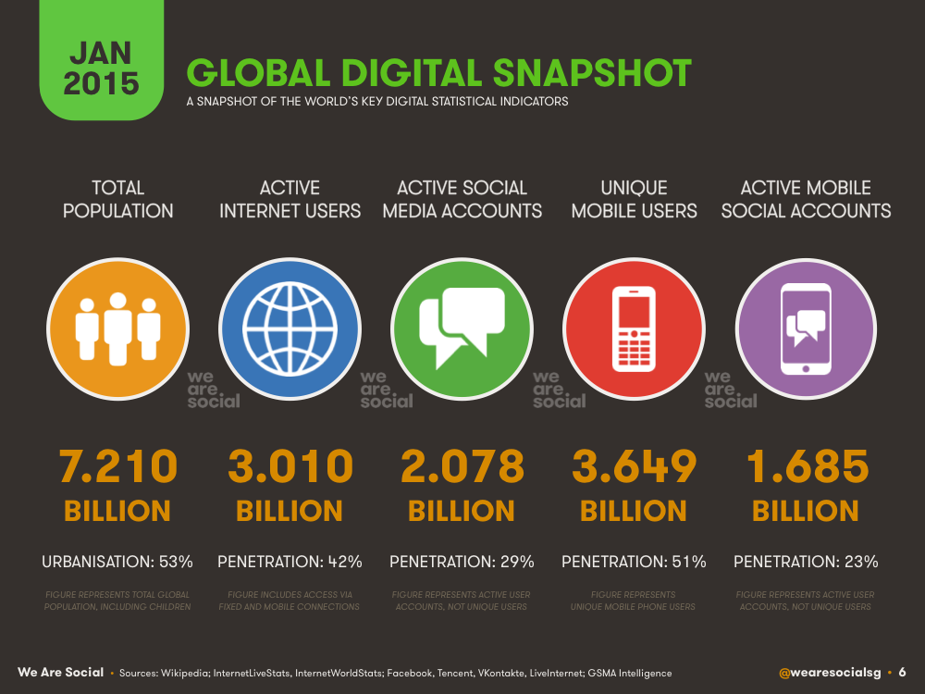
Health Care Social Media. “2015 WorldWide Internet, Mobile, and Social Media Trends Report,” January 27, 2015.
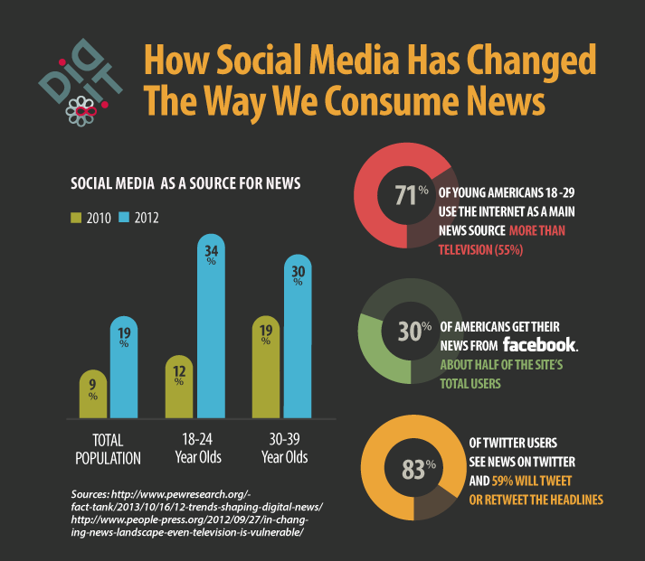Skenderian, Ashley. “News at your fingertips,” Medium. September 30, 2019.

