Human Rights Education Curriculum Integration Guide Project

LESSON TITLE: The Industrial Revolution & Workers’ Rights

RECOMMENDED GRADE LEVEL(S) FOR IMPLEMENTATION: 9-10

INSTRUCTIONAL TIME OR CLASS SESSIONS REQUIRED: At least 9 days of in-class instructional time, based on a 45 minute class schedule, or at least 5 days of in-class instructional time, based on a 80 minute block schedule

LESSON AUTHOR: John Terry

AUTHOR AFFILIATION (SCHOOL OR OTHER INSTITUTION): Wayne Township Public Schools

BRIEF DESCRIPTIVE SUMMARY OF LESSON

The purpose of this lesson is to introduce students to the effects that the development of industrial capitalism had on industrial workers in Europe and the United States in the 19th century, to introduce students to the Universal Declaration of Human Rights as an instrument by which they can understand and measure industrial workers’ rights with human rights issues, and to allow students to apply their understanding of workplace issues as human rights issues to contemporary scenarios involving workers’ rights.

NJ CORE CURRICULUM STANDARDS ADDRESSED IN LESSON

A. 6.1.12.D.5.b Evaluate how events led to the creation of labor and agricultural organizations that protect the rights of workers.

B. 6.2.12.C.3.d Determine how, and the extent to which, scientific and technological changes, transportation, and new forms of energy brought about massive social, economic, and cultural changes.

C. 6.2.12.D.3.b Explain how industrialization and urbanization affected class structure, family life, the daily lives of men, women, and children, and the environment.

D. 6.2.12.A.5.e Assess the progress of human and civil rights around the world since the 1948 U.N. Declaration of Human Rights

E. 6.3.12.A.2 Compare current case studies involving slavery, child labor, or other unfair labor practices in the United States with those of other nations, and evaluate the extent to which such problems are universal.

COMMON CORE CURRICULUM STANDARDS REFERENCED IN LESSON

1. CCSS.ELA-LITERACY.RH.9-10.1: Cite specific textual evidence to support analysis of primary and secondary sources, attending to such features as the date and origin of the information.

2. CCSS.ELA-LITERACY.RH.9-10.2: Determine the central ideas or information of a primary or secondary source; provide an accurate summary of how key events or ideas develop over the course of the text.

3. CCSS.ELA-LITERACY.RH.9-10.7: Integrate quantitative or technical analysis (e.g., charts, research data) with qualitative analysis in print or digital text.

4. CCSS.ELA-LITERACY.RH.9-10.9: Compare and contrast treatments of the same topic in several primary and secondary sources.

5. CCSS.ELA-LITERACY.WHST.9-10.7: Conduct short as well as more sustained research projects to answer a question (including a self-generated question) or solve a problem; narrow or broaden the inquiry when appropriate; synthesize multiple sources on the subject, demonstrating understanding of the subject under investigation.

6. CCSS.ELA-LITERACY.WHST.9-10.8: Gather relevant information from multiple authoritative print and digital sources, using advanced searches effectively; assess the usefulness of each source in answering the research question; integrate information into the text selectively to maintain the flow of ideas, avoiding plagiarism and following a standard format for citation.

7. CCSS.ELA-LITERACY.WHST.9-10.9: Draw evidence from informational texts to support analysis, reflection, and research.

LITERACY DEVELOPMENT CONNECTIONS IN LESSON

A. (See Common Core Curriculum standards listed above)

LESSON GOALS/OBJECTIVES—Students will be able to:

1. Explain the motivations for actors in an industrial capitalist economy, and the choices available to those who own businesses in order to maximize profits.

2. Identify patterns in industrial workplaces regarding working conditions, compensation, and related issues, using primary sources from the early industrial era.

3. Define human rights and classify human rights as civil/political rights or social/economic rights.

4. Apply understanding of human rights framework to workplace issues in history.

5. Assess the options available to workers, and workers’ advocates, to address human rights issues in the workplace.

6. Conduct research on a contemporary workplace issue, and construct a presentation that describes the issue, applies the human rights framework to the issue, and determines a course of action for addressing the workplace issue.

LESSON METHOLODOGY AND PROCEDURES

Part 1 (can be done in two 45 min. class periods or one 80 min. block period)

Overview: Students are to build an understanding of the historical background regarding the causes of industrial revolution in England in the late 18th and early 19th century. Students are to be introduced to the concepts of industrialization and capitalism, and work through an exercise that will help them understand the motives and behaviors of business owners and of workers in industrial capitalism.

Preparation for lesson: It is recommended that students have done some reading in advance (for example, from their assigned textbook) on the historical causes of the industrial revolution in England. (If textbooks are not available, teachers can assign relevant portions of “The History of the Industrial Revolution” article found in New World Encyclopedia online.)

1. Anticipatory set: What do you own that is made by machine? What do you own that is made by hand? Which of the items you identified are less expensive, and which items are more expensive? What do you think is the connection between machine-made goods and the cost of the goods? Is there anything that you own that you made yourself? Why or why not? Pair/share: students discuss responses to the above questions with a partner, and then share with the class as a whole. Students should be briefed on how most of the goods we own today are produced in an industrial process, and that the less it cost someone to produce those goods, the cheaper they are for us as consumers.

2. Historical background: Review reading assignment and/or brief direct instruction on how England gradually moved to a more industrial economy in the late 18th and early 19th centuries.

3. Introduction of concepts: In brief lecture, introduce students to the concept of capital, as (1) any produced item (ex: machine, equipment, building) that could be used to enhance workplace production, and (2) funds that could be spent on such items, all of which advance the goal of generating profit. Consider also introducing students to other forms of capital (ex: human capital, social capital, cultural capital), and how they work as investments in production. Students should then be introduced to capitalism as an economic system which depends on people making capital investment in order to make profit. Industrial capitalism, in particular, is related to the production of goods for sale, in order to earn a profit. Students could also be introduced to terms such as “entrepreneur” or “capitalist” to describe someone who makes capital investment in the hope of making a profit.

4. Exploring concepts and understanding motives of actors in capitalism: “How Can Entrepreneurs Control Costs?” reading assignment (adapted from materials provided by the Council for Economic Education, New York NY, “Entrepreneurship in the U.S. Economy, Lesson 20”). Through the reading, students are exposed to the different kinds of costs (fixed costs and variable costs) an entrepreneur has to take on in order to run a business, (through the example of owning a shoe store), and the types of decisions an entrepreneur can make in order to cut costs, and therefore, enhance profits. Students should be encouraged to reflect on how the decisions made by entrepreneur can potentially affect workers, as well as society at large, or the environment.

5. Potential extension activity: “Taking Care of Business” (also adapted from materials provided by the Council for Economic Education, see above). Students tally costs per day of running a submarine sandwich shop, and then use this quantitative information to make decisions as a business owner, with regard to which costs to cut.

HW (reading assignment): Students should read about the move toward a more industrial society in late 18th / early 19th century Europe and the U.S., especially with regard to the building of factory towns, and the nature of factory work. This could be done using their textbooks, or the New World Encyclopedia. Ask students to make a connection between the previous day’s lesson and their homework reading: Why might factory owners have created or allowed the kinds of conditions we see in these industrial cities and factories?

Part 2 (can be done in one 45 min. class period, or for a portion of an 80 min. block period)

Overview: Students are to learn about the nature of industrial work, through readings and analysis of secondary and primary source materials.

Preparation for lesson: Have students read about factory life and work during the late 18th and early 19th centuries. Post primary source materials around the classroom in preparation for the gallery walk. (Suggestions for specific primary sources listed under “Factory Work and Life Primary Sources” in the Resources section of this lesson)

1. Anticipatory set: More and more people were moving to industrial cities in England in the late 18th and early 19th centuries, many of whom were looking for work in textile factories. Moreover, for many decades, many of these factory workers were children your age or younger. Imagine you are one of these young people in England. Why are you looking for factory work in the city? What might you have to do in order to get a job? What challenges might you experience while working in a factory? Ask students to write an interior monologue – that is, imagine they are in the position of a person who may or may not have existed in history, and write a brief explanation about who that person may be - in response to the above scenario and questions.

2. Historical background: Review reading assignment and/or brief direct instruction on how England gradually moved to a more industrial economy in the late 18th and early 19th centuries. Include explanation of terms and concepts: urbanization, factory, mass production, exploitation.

3. “Factory Life & Labor” Gallery Walk: Assign students to pairs with whom they will circulate the room, finding primary sources of their choice that help them fulfill the requirements of the scavenger hunt (see “Factory Work & Life Gallery Walk / Scavenger Hunt” worksheet). Periodically (approx. every 5 minutes) ask students to wrap up their analysis of the source and move on to the next source. Students should examine at least 3, and up to 6, sources, depending on time available for instruction. ELL students should be directed to sources based on accessibility, for example, sources that may be more visual.

4. Writing reflection from Gallery Walk: 1) How do you feel in response to what you have examined today? 2) What problems can you say existed in factories or factory towns in the early industrial era? Use evidence from the documents you examined to support your conclusions. 3) What rights, if any, do you think these workers had? 4) What solutions might people present to these problems? How might they try to go about achieving these solutions?

Potential extension assignments: Invite a guest speaker, such as a unionized factory worker to speak to the class. Take students on a field trip to a site of labor or industrial-era history (ex: The American Labor Museum in Haledon, NJ or the Tenement Museum in New York City).

HW (reading assignment): Assign students reading (from their textbook or from New World Encyclopedia) on the establishment of labor unions and the union movement.

Part 3 (can be done in one 45 min. class period or for a portion of an 80 min. block period)

Overview: Students are introduced to the Universal Declaration of Human Rights (UDHR) through a brief history on rights, and explanation of different categories of rights (i.e. civil and political rights, and social and economic rights). Students are asked to re-define workers’ issues of the early industrial era as human rights, and then learn about the formation of the early labor movement, and the ways in which labor unions advocate for the rights of workers.

1. Anticipatory set: Think of a right that you believe all humans should have and write it down. Students pair and share responses with class, while teacher records students’ ideas on board. Indicate to students that you will be returning to their list during the lesson.

2. Direct instruction: Briefly review and recap with students previous course content on the American and/or French Revolutions, in which people fought for, and secured some political and civil rights. Students record examples of civil and political rights they are familiar with from the French Declaration of the Rights of Man & Citizen or the U.S. Bill of Rights on T-charts. Extension: The teacher can also ask students to make notes of any limitations they were aware of (i.e. the right to vote did not apply to women yet).

3. Class read aloud: Students take turns reading aloud an explanation of civil and political rights, and an explanation of social and economic rights, which includes a brief history on how these rights were articulated at different moments in world history. Then, briefly introduce students to specific items from the UDHR dealing with social and economic rights.

4. Application: Students return to their notes (or original sources) from the gallery walk in the previous lesson. Students then have to identify examples of labor issues they took notes on the day before, and explain how they are examples of human rights issues. Students can also be introduced at this point to labor rights conventions and treaties, such as the International Labour Organization (ILO) (https://www.ilo.org/global/standards/introduction-to-international-labour-standards/), or the International Covenant on Economic, Social, and Cultural Rights (https://www.ohchr.org/en/professionalinterest/pages/cescr.aspx).

5. Homework review & discussion: Discuss the first labor unions and ways they took action to demand fairer treatment of workers from employers and from governments. Students take notes on examples of workplace reforms passed by governments in response to the demands of labor unions (ex: child labor laws, limiting the work week to 40 hours, paid sick leave, employer-paid health insurance, minimum wage, Occupational Safety & Health Act (OSHA), whistleblower protections, pensions, overtime pay, the right to strike, wrongful termination laws, etc.)

HW (at teacher’s discretion, to potentially save time in next lesson): “Background” reading from “Workers’ Responses to Exploitation and Oppression in Early Industrial Britain” lesson from Youth, Unions, and You.

Part 4 (can be done in two 45 min. class periods or one 80 min. block period)

Overview: Students learn about the historical background, and purpose of, the labor union movement. Through a simulation/webquest activity (adapted from materials produced by the British Columbia Federation of Labour & British Columbia Teachers’ Federation), students investigate potential responses by workers to exploitative conditions in 19th century Britain, and prepare brief presentations to the class based on their findings.

1. Anticipatory set: Imagine you are one of the hundreds (or thousands) of workers in one of the shops you learned about in the gallery walk [see previous lesson]. What would happen if you and SOME of the other workers approached your employer to demand change? What would happen if you and ALL of the workers, as a collective, approached your employer to demand change? What different types of outcomes might be possible?

2. Direct instruction: Background on industrial Great Britain in the early 19th century. Background should include overview of early union movement, as well as obstacles and problems related to anti-union politics and culture (ex: the Combination Acts), and place emphasis on the fact that this was, and still remains, an ongoing struggle for workers’ rights that has, at times, been violent. Recommended lyrical analysis of “Which Side Are You On?” recorded by Pete Seeger or “There Is Power in a Union” recorded by Billy Bragg. See “Background” reading from Youth, Unions, and You as a guide, or to use as assigned reading.

3. Simulation / Webquest: Use the lesson on “Workers’ Responses to Exploitation and Oppression in Early Industrial Britain – TEN OPTIONS” to engage students in role-playing and research from the perspective of early industrial workers in Great Britain, to learn what options these workers had before them, and how they attempted to respond to their issues. Introduce students to the problem, the options before them, and assign them to one of five different groups, who have the task of learning about one particular way in which workers tried to improve their conditions. Make sure students are able to apply their understanding of the UDHR to describe what kinds of human rights these workers did not have access to and were responding to. Students conduct research using suggested resources (see lesson plan below for more details), and make brief presentations of their findings (could be using PowerPoint or Google Slides) in “jigsaw” groups with their classmates.

4. Student reports: Students share their findings with the rest of the class, while classmates take notes using graphic organizer.

5. Reflection and class discussion: Which groups do you think were most effective in attaining human rights at the time? Which groups do you think were most effective in attaining human rights in the long run? What might be the advantages or disadvantages some tactics might have (weigh risks and benefits)? Which strategies might work well for achieving human rights in the short-term? Which might work well for human rights in the long-term? Who gets included, and who gets left out? Students write brief responses to the questions posed here, and then discuss as a class.

Part 5 (at least two 45 min. class periods or one 80 min. block period – group work to conduct research and develop presentations can be assigned for homework, or additional class time will be needed)

Overview: In this part of the lesson, students are to work in groups and conduct research on present-day labor issues, and also define the scope of these issues using their understanding of human rights. Students are then to use their research findings to develop brief presentations to share with the class in a “Labor Summit.”

1. Research: Students work in groups (they can be teacher-assigned or self-selected) to identify a present-day labor issue. A great place to start is the “Business” section of the Human Rights Watch website (can be accessed at: https://www.hrw.org/topic/business). Students can use articles posted here as source material for their research but should also use information posted on Human Rights Watch as a springboard for further research. Students should be consulting additional resources to learn more about the issue (ex: newspapers like The New York Times, magazines such as The Economist, or other resources available through school-based databases, such as EBSCOHost, Newsela, etc.) Students should find no less than 3 sources about the present-day labor issue of their choice. Students should also apply their understanding of human rights, via the UDHR, to explain how the workers’ rights issue is a human rights issue.

2. Develop strategy: Distribute “Tactics for Addressing Workers’ Issues” handout to students. Students are to use this handout, as well as lessons learned from the “Workers’ Responses” webquests and presentations (see previous part of lesson) to help them develop a strategy that they would use as a group of workers in order to address the issue. The strategy should also involve the work that other stakeholders (i.e. consumers, citizens, advocacy groups) could do in order to support the efforts of their union to address the labor issue. Students should be evaluating the pros and cons of their chosen strategy, with regard to risks and benefits, as well as long-term and short-term effectiveness in achieving workers’ (i.e. human) rights.

3. Development of presentations: Students work with groups to develop presentations (using PowerPoint, posters, etc.) that include an explanation of the issue (including how the issue is a human rights issue), as well as the strategy they would use in an attempt to address the issue.

Part 6 (recommended 10 min. per presentation. Consider grouping different presentations by topic, and follow with 15 min. Q & A session. Depending on number of students, the student conference will most likely take more than one class period, or can be scheduled outside of regular class time, depending on school environment)

Overview: Students participate in a “Labor Summit for Workers’ Rights.”

1. Students participate in a Labor Summit for Workers’ Rights in which they share their research on a specific workers’ rights violation that takes place today, on how that specific labor issue is a human rights issue, and what kind of strategy and plan would be effective for tackling the issue.

As non-presenting students observe presentations, these students should be serving as peer evaluators and developing questions for the subsequent Q & A session. Peer evaluations are to be completed using a worksheet.

2. Q & A session with audience.

3. Students freely associate, discuss action plans, solicit proposals for coordination, and/or share contact information.

ASSESSMENT OF STUDENT PERFORMANCE

A. Worksheet and brief writing assignment: “How Can an Entrepreneur Control Costs?” and “Taking Care of Business”

B. Worksheet and brief writing assignment: “Factory Work & Life Gallery Walk / Scavenger Hunt”

C. Note-taking assignment on human rights, and classes of human rights

D. Webquest (including brief oral presentations): “Workers’ Responses to Exploitation and Oppression in Early Industrial Britain – TEN OPTIONS”

E. Labor issues research & action plan presentation

LEARNING RESOURCES (THOSE USED IN THIS LESSON)

1. New World Encyclopedia. “The History of the Industrial Revolution.” http://www.newworldencyclopedia.org/entry/History_of_the_Industrial_Revolution

2. Council for Economic Education. “How Can Entrepreneurs Control Costs?” & “Taking Care of Business” activities. Retrieved from https://www.unomaha.edu/college-of-business-administration/center-for-economic-education/teacher-resources/9-12/how-can-entrepreneurs-control-costs.pdf

3. “Factory Work & Life Primary Sources” (available in two separate files – one with sources that are vertically oriented, the others in landscape orientation) and “Factory Work & Life Gallery Walk / Scavenger Hunt” worksheet.

4. Lincoln University. Civil and Political Rights. Retrieved from http://www.lincoln.edu/criminaljustice/hr/Civilandpolitical.htm

5. Amnesty International. Human Rights for Human Dignity: Economic, Social, and Cultural Rights. Retrieved from https://www.amnesty.org/en/what-we-do/living-in-dignity/

- United Nations. The Universal Declaration of Human Rights. Retrieved from http://www.un.org/en/documents/udhr/

- “Classes of Human Rights” worksheet

- “Introduction to International Labour Standards.” International Labour Organization (ILO). Retrieved from https://www.ilo.org/global/standards/introduction-to-international-labour-standards/.

- United Nations. The International Covenant on Economic, Social, and Cultural Rights. Retrieved from https://www.ohchr.org/en/professionalinterest/pages/cescr.aspx

- British Columbia Teachers’ Federation and the British Columbia Federation of Labour. “Workers’ Responses to Exploitation and Oppression in Early Industrial Britain – TEN OPTIONS” lesson plan, from the Youth, Unions, and YOU Teacher’s Guide. Retrieved from https://bctf.ca/uploadedFiles/public/TeachingResources/YouthUnionsYou/SS9_L3.pdf

- Workers’ Responses to Exploitation and Oppression in Early Industrial Britain – TEN OPTIONS” graphic organizer

- “Tactics for Addressing Workers’ Issues” handout. Includes materials from the UE (retrieved from https://www.ueunion.org/org_steps.html), the Economic Policy Institute (retrieved from https://www.epi.org/publication/how-todays-unions-help-working-people-giving-workers-the-power-to-improve-their-jobs-and-unrig-the-economy/), the AFGE (retrieved from https://www.afge.org/take-action/afge-on-capitol-hill/lobbying-dos-and-donts/), and the International Brotherhood of Teamsters (https://teamster.org/content/definitions-common-labor-terms#j)

- “Contemporary Labor Issues” student research and planning worksheet

EXTENSION RESOURCES

A. Stephen A. Sweet & Peter F. Meiskins. Changing Contours of Work: Jobs and Opportunities in the New Economy, Third Edition. From Sociology for a New Century Series. Thousand Oaks, CA: Sage Publications, 2016.

B. Eileen Boris & Nelson Lichtenstein, eds. Major Problems in the History of American Workers, Second Edition. From the Major Problems in American History series. New York: Houghton Mifflin, 2003.

C. Amnesty International. (2014). Human rights for human dignity: A primer on economic, social, and cultural rights. Second edition. Retrieved from https://www.amnesty.org/en/documents/POL34/001/2014/en/

D. British Columbia Teachers’ Federation and the British Columbia Federation of Labour. Youth, Unions, and YOU: A Secondary Teacher’s Guide to Labour Studies for B.C. Schools. 2001. https://bctf.ca/uploadedFiles/public/TeachingResources/YouthUnionsYou/index.html

E. Bill Bigelow & Norm Diamond. The Power in Our Hands. Zinn Education Project, 1988.

F. Michael D. Yates. Why Unions Matter, Second Edition. Monthly Review Press, 2009.

G. United Nations. “International Convention on the Protection of the Rights of Migrant Workers and Members of Their Families.” 1990. https://treaties.un.org/Pages/ViewDetails.aspx?chapter=4&lang=en&mtdsg_no=IV-13&src=IND

H. International Labour Organization. “Domestic Workers Convention.” 2011. https://www.ilo.org/dyn/normlex/en/f?p=NORMLEXPUB:12100:0::NO::P12100_INSTRUMENT_ID:2551460

I. Pete Seeger. “Which Side Are You On?” Pete Seeger’s Greatest Hits. 1967. CD (re-released in 2002).

J. Billy Bragg. “There Is Power in a Union.” Talking with the Taxman About Poetry. 1986. CD.

K. Barbara Kopple. Harlan County, USA. 1976. Released by Criterion Collection on DVD in 2006.

L. Bertolt Brecht. “Questions from a Worker Who Reads.” 1935. Available at https://www.marxists.org/subject/art/literature/brecht/

MODIFICATIONS OR ADAPTATIONS OF THE LESSON FOR DIFFERENTIATED LEARNERS

1. Active reading handout with worksheet is available as scaffolding to assist students with comprehension and analysis of textual materials.

2. Vocabulary terms for assigned readings could be provided in advance.

3. Research-based assignments could be scaffolded and chunked accordingly. For example, contemporary labor issues could be identified in advance by instructor for students to research. Presentations can also be further delineated for classified or ELL students. For example, slides 1 & 2 can be an introduction of the workers and the setting; slides 3 & 4 can describe the work that is done; slides 5 & 6 can identify how the work is a human rights issue, by relating to the UDHR; slides 7 & 8 can propose actions taken by, or on behalf of, the workers; and slides 9 & 10 can describe the resolution or goal that the students would be hoping to achieve.

4. ELL students can research workers’ rights in their native countries or regions of the world from which they have emigrated. Moreover, Human Rights Watch makes a great deal of their information available in a number of different languages, which these students can access. For further differentiation, ELL students can create presentations that are visual-based, that include brief 3-5 sentence captions for each image in the presentation.

4. Student roles within group activities could be designated by instructor.

5. Assignments could be streamlined by removing evaluation of actions/tactics from lessons.

Active Reading

In the social studies classroom, it is important to practice critical reading skills. In a world flooded with information, we are responsible for identifying key components of texts, and critically evaluating texts, not only as citizens participating in democratic government, but as human beings who need to be fully aware of and engaged with their world. One skill we can develop to achieve these goals is known as “Active Reading.”

According to Penn State University, “active reading skills act as a catalyst for critical thinking skills that must be applied in a systematic way” and, put simply, are a way to get you more “involved in the material.”

Here are some basic steps you can use to approach active reading:
- Ask yourself pre-reading questions and take a few brief notes: What is the topic, and what do you already know about it?
- Bracket the main idea or thesis of the reading and put an asterisk next to it.
- As you read, collect major clues. You can do so by answering the following questions: Who? What? When? Where? Why? How? Point of view?
- Circle any unfamiliar terms and define them.
- Make notes or comments in the margins of the text. Notes and comments could and should be about any prior knowledge you have that comes to mind as you read. In other words, how is the text you are reading connected with something you already learned? Prior knowledge added to new textual information can help you draw an inference, which is a conclusion you can draw based on evidence in the text, but that is not explicitly stated by the text.
- Write any questions you have in the margins and try to answer them independently after reading the text. If you cannot answer your question independently, be prepared to share and discuss your question in class.

Active Reading Worksheet

Pre-Reading Notes:

Main idea / Thesis (in your words):

Collect the Clues

Who:

When:

Where:

Why:

How:

Point of View:

Unfamiliar Terms:

Inferences / Conclusions:

Remaining Questions:

How Can Entrepreneurs Control Costs?

Anyone who runs a business knows that some costs must be paid no matter how many products are offered for sale. For example, Alex owns a shoe store. He must pay his property taxes whether he sells 20 or 200 pairs of shoes each day. Mortgage payments (payments on the loan he took out to buy his building) must be made to the bank. Fire insurance, the lease on a delivery truck, and installments on a remodeling loan are other examples of costs Alex must pay regardless of sales. Expenses that must be paid no matter how many goods or services are offered for sale are called fixed costs. Other types of costs change with the number of products offered for sale. These are called variable costs. Variable costs include the wages of production workers or salespeople, raw materials, electric power to run machines, and the cost of maintaining inventory. If Alex decides to offer more types of shoes for sale, he will need to hire more people to stock and sell these items. Alex's inventory costs will grow as well as his shipping costs for any products that he either buys or sends to customers. These are all examples of variable costs.

Entrepreneurs need to understand the important differences between fixed and variable costs and how these differences affect a firm's success. Fixed costs must be paid. Sometimes they are called "sunk costs" because at the present they are beyond the control of the entrepreneur. If Alex has signed a lease for his store that requires a $1,000 payment each month, he must make the payment no matter how many products he offers for sale. The only costs an entrepreneur has immediate control over are variable costs. Alex may be required to pay rent for his shoe store, but he can choose how many salespeople to hire or how many products to stock. The fact that entrepreneurs cannot change their fixed costs at the present does not mean they should ignore them. Fixed costs are generally paid out of the money earned from an entrepreneur's sales. If the entrepreneur can sell more products to earn more money, the fixed costs will be a smaller part of income…

…Entrepreneurs often try to increase their sales to reduce the amount of fixed costs paid per item sold. This explains why many gas stations have become convenience stores in recent years. If the owner has to pay to have a building and someone there to help customers, it doesn't cost much more to sell milk and bread, too. As the result of selling other products, total sales increase. This reduces the amount of fixed costs that must be paid out of each dollar of sales, thus increasing profit.

Although it is possible to improve a firm's profitability by offering more types of products, there is no guarantee this approach will always work. Entrepreneurs must keep track of their variable costs. Suppose the owners of a store spent an extra $250 a week to offer fresh lettuce and other produce for sale. If they sold only $150 worth of the produce, they would lose $100 because the amount earned in sales is not sufficient to pay the variable costs of stocking the fresh vegetables and fruit. An entrepreneur should never offer a product for sale that cannot pay for its variable costs.

Entrepreneurs need to understand the difference between fixed and variable costs. They should realize that the profit per item can be increased when more products are sold because the fixed cost per item is less. Steps to limit the amount of fixed costs a firm is responsible for often improve its chances for success.

Check Your Understanding

- What is a “fixed cost” and what are some examples of this?

- What is a “variable cost” and what are some examples of this?

- How can a firm control its variable costs?

- How can a firm control its fixed costs per unit sold?

Drawing Inferences & Connecting to Class

- How might factors of production play a role here? How might the availability of certain kinds of resources or materials help an entrepreneur?

- What are some behaviors we might expect to see from entrepreneurs due to the pressures of a capitalist economic system? What effect might these behaviors have on society or the environment?

TAKING CARE OF BUSINESS

How much would it cost to run a submarine sandwich shop in your community? Look through the classified or real estate advertisements in your local newspaper and identify a building that could be rented. Find the cost of rolls, meat, cheese, lettuce, and so forth that would be needed per sandwich. (For help in determining prices, visit your local supermarket, or use the supermarket ads in the weekly food edition of the local newspaper.) Determine what you would have to pay your help (two workers at all times). Assume you sell 200 submarine sandwiches per day when you stay open from 10:00 AM to 8:00 PM. Write this information in the column at the left below. Then answer the questions that follow.

Costs of Running a Submarine Sandwich Shop

ITEM | COST PER DAY | FIXED OR VARIABLE?
Rent per day (monthly rent= $_3000_____, daily rent = $______(divide by 30) | $________ | ________
Cost of insurance per day ($240/month) | $________ | ________
Utilities ($360/month) | $________ | ________
Cost of employees (local wage = $__10_per hour, daily wages = $____x 10 hours x 2 workers, add 20% for fringe benefits) | $________ | ________
Cost of 200 rolls | $___120_____ | ________
Cost of meat and condiments | $___400____ | ________
Cost of 200 bags and napkins | $_____5___ | ________
Cost of 200 soft drinks | $____75____ | ________
TOTAL | $________ | ________

Solving the Problem At Hand

- In the fixed­or­variable column, write F for fixed costs and V for variable costs.

- How much would you need to charge per sandwich to earn 5 percent return on your sales?

To find the answer, proceed as follows:

- Multiply total costs times 1.05 to find the amount you must take in from sales.

_________________ x 1.05 = _________________

- Divide the amount you must take in by 200 sandwiches, and you have the price you must charge per sandwich.

_________________ divided by 200 = ______________ (price)

- What are some potential ways you could increase your profit margin? Are there any variable costs you could try to cut down on? Are there any ways you could reduce the fixed cost per sandwich sold? If so, how?

Drawing Inferences / Connecting to Class

- What factors of production would help you as an entrepreneur in this situation? Why?

- What role could the government play in assisting you as an entrepreneur? What kind of legislation might benefit you as an entrepreneur?

- How might you advocate for yourself? Would everyone in society agree with you? Who might agree? Who might disagree? Why or why not?

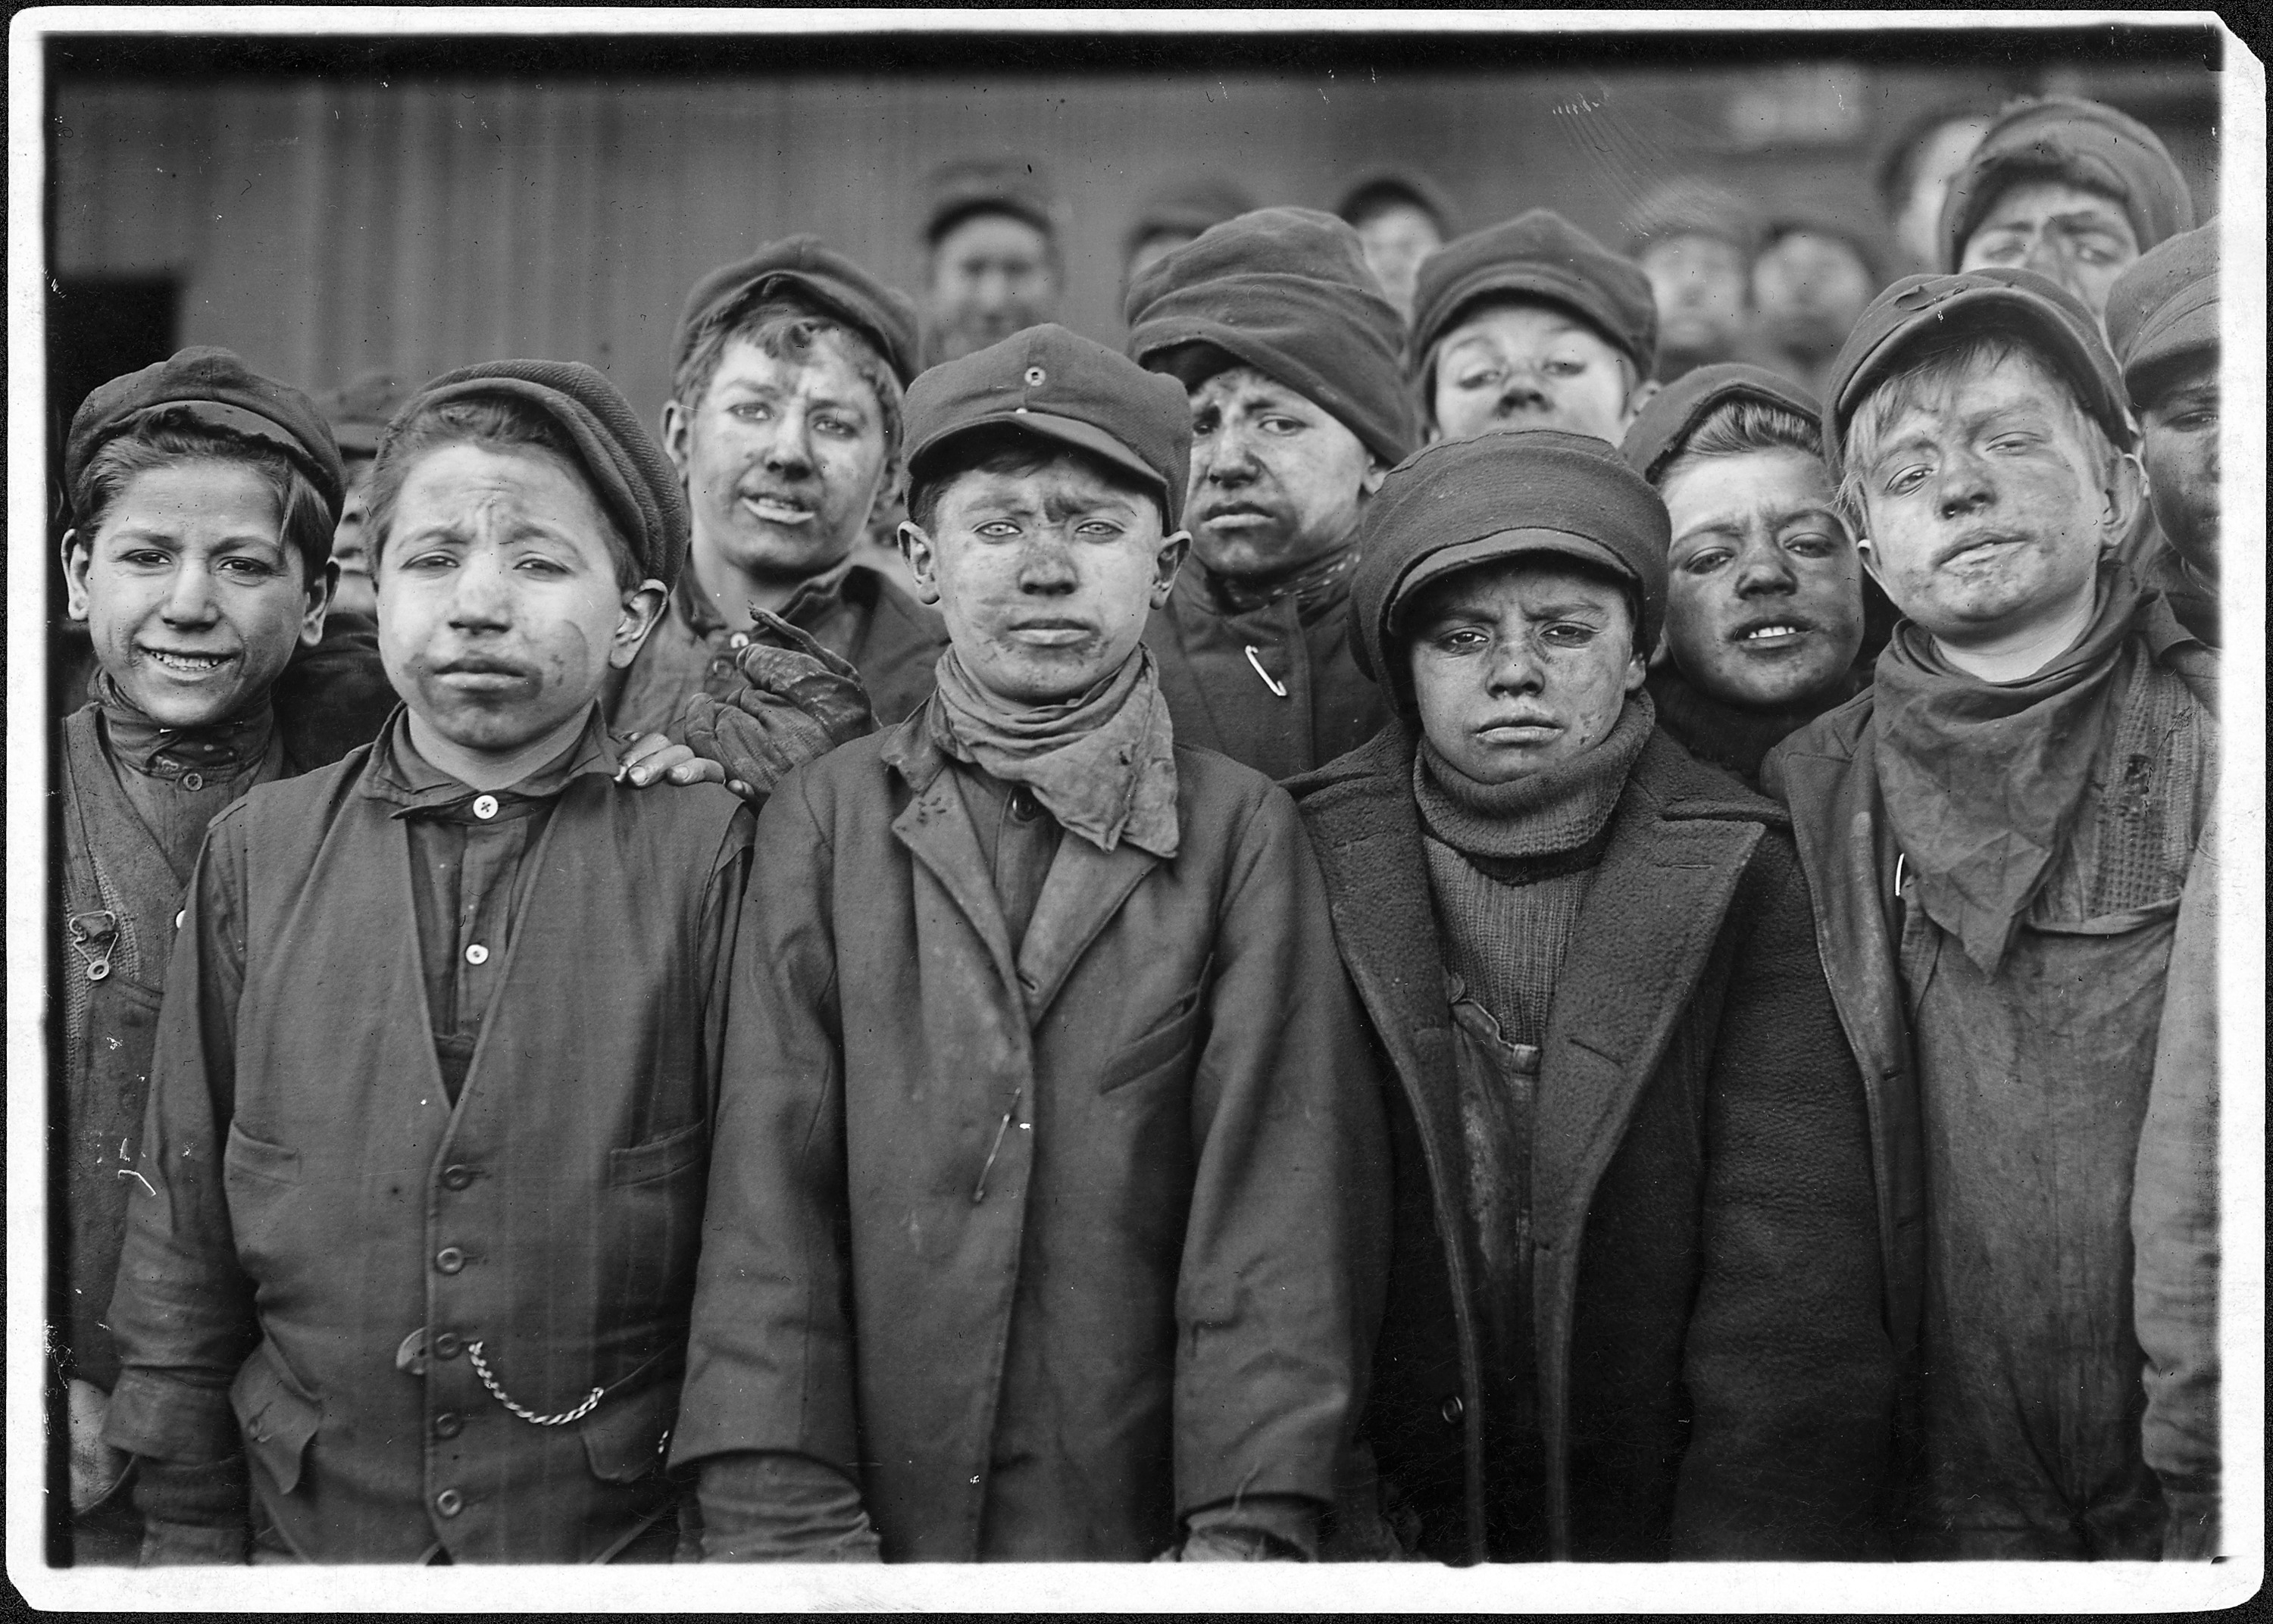

Source: Breaker Boys. Smallest is Angelo Ross. Hughestown Borough Coal Company, Pittson, Pa. [photograph taken at a Pennsylvania coal mine, January 16, 1911]
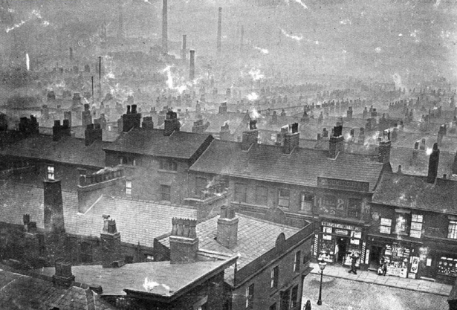

Source: photograph of rooftops in Ancoats, neighborhood in Manchester, England, 1870

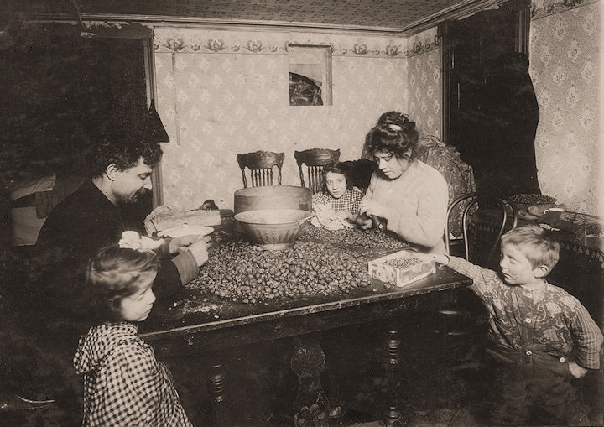
Source: Italian family pick nutmeats, photograph by Lewis Hine, a family picking nuts for dinner, in a dirty basement apartment in New York City, 1911
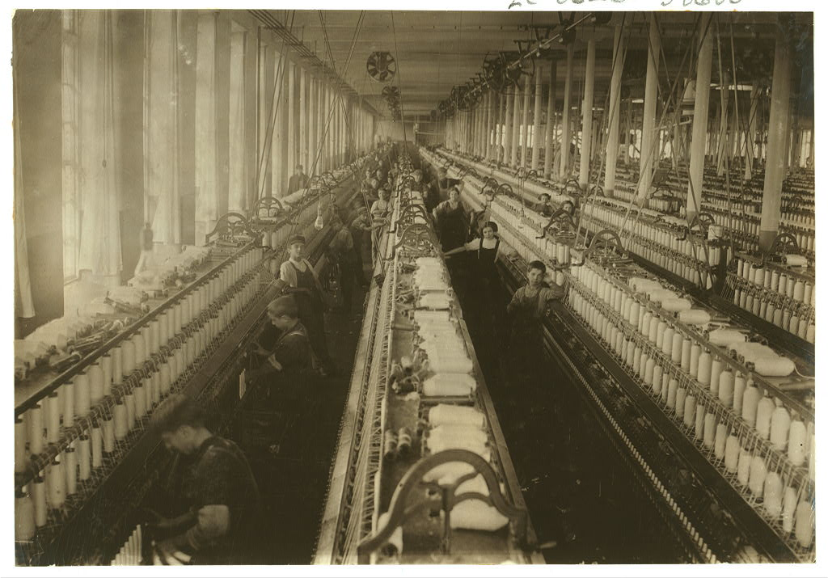
Source: “General view of the spinning room, Cornell Mill, showing some of the young boys and girls employed there.” Cornell Mill, Massachusetts. Photography by Lewis Hine, January 1912

A report on Manchester textile workers by a medical doctor:

“Prolonged and exhausting labour, continued from day to day, and from year to year, is not calculated to develop the intellectual or moral faculties of man. The dull routine of a ceaseless drudgery, in which the same mechanical process is incessantly repeated, resembles the torment of Sisyphus—toil, like the rock, recoils perpetually on the wearied operative. The mind gathers neither stores nor strength from the constant extension and retraction of the same muscles. The intellect slumbers in supine inertness; . . . To condemn man to such severity of toil is, in some measure, to cultivate in him the habits of an animal

From James P. Kay, The Moral and Physical Conditions of the Working Classes Employed in Cotton Manufacture in Manchester, 1832

A comment on Manchester textile workers by a manufacturer [factory owner]:

“I have visited many factories, both in Manchester and in the surrounding districts, and I never saw children in ill-humour. They seemed to be always cheerful and alert, taking pleasure in the light play of their muscles—enjoying the mobility natural to their age. The scene of industry, so far from exciting sad emotions in my mind, was always exhilarating . . . . The work of these lively elves seemed to resemble a sport, in which habit gave them a pleasing dexterity. Conscious of their skill, they were delighted to show it off to any stranger.”

From Andrew Ure, Philosophy of Manufactures, (1835)

Report by the owner of a textile factory in Lille, France:

“It is simply false to equate the hours of work in our factories with arduous work. My workers, for example, in principle put in ninety hours a week, but I am lucky to get seventy -two hours of work from them. They seize on any occasion to wander around the factory or even walk outside, and to chatter with each other. Sometimes I think that they do not know what work is, and can be made to work only against their will. Really, they are like children, but I wish we could get them to work as hard as our own schoolboys work. I will admit only that my second generation of workers, who grew up in the factory, are somewhat more amenable.”

From Archives Nationales de France, F124705, “Report of Barrois,” 1837

Management report filed in 1888 by a Ruhr [Germany] coal-mining company:

“Another very disturbing and damaging factor is the high turnover of workers, which, along with absenteeism, is always a problem. Workers change jobs for various reasons, but in part simply to get some time off from work. They show little concern for maintaining their skill or productivity, for they believe that they are pushed to produce more than men ought to produce in any event, and that if they work too hard the company will simply cut their pay, to get the profit, or reduce the number of jobs and so throw many workers into unemployment. They talk of the old days, when they were not driven so hard. The same feeling causes some of the resistance to overtime shifts, though of course other workers are eager for such shifts to earn extra money.”

From Gerhard Aldelmann, Quellensammlung zur Geschichte der sozialen Betriebsverfasung: Ruhrindustrie (Collected Sources on the History of the Social Management —Worker Agreements in Industry in the Ruhr Area), Reprinted in Bonn, Germany 1965

Thomas Wilson, Esquire, owner of three coal mines in England. Testimony to the Sadler Committee on Child Labor

“I object on general principles to government interference in the conduct of any trade, and I am satisfied that in the mines it would be productive of the greatest injury and injustice. The art of mining is not so perfectly understood as to admit of the way in which a colliery shall be conducted being dictated by any person, however experienced, with such certainty as would warrant an interference with the management of private business. I should also most decidedly object to placing collieries under the present provisions of the Factory Act (regulated the employment of children and women) with respect to the education of children employed therein. First, because, if it is contended that coal-owners, as employers of children, are bound to attend to their education, this obligation extends equally to all other employers, and therefore it is unjust to single out one class only; secondly, because, if the legislature asserts a right to interfere to secure education, it is bound to make that interference general; and thirdly, because the mining population is in this neighborhood so intermixed with other classes, and is in such small bodies in any one place, that it would be impossible to provide separate schools for them.”

Source: Sadler Committee report, published 1832

Impressions of a Manchester spinner [textile worker], 1818:

“Locked up in factories eight stories high, [the worker] has no relaxation till the ponderous engine stops, and then he goes home to get refreshed for the next day; no time for sweet association with his family; they are all alike fatigued and exhausted. This is no over-drawn picture: it is literally true . . . . When the spinning of cotton was in its infancy, there was work for all, and at a proper pace, and in the community of family and friends. This was before those terrible machines for superseding the necessity of human labour, called steam engines, came into use . . . and workmen lost their power over their labor.”

Recollection of a child laborer in a British textile mill:

“For several years after I began to work in the mill, the hours of labour at our works did not exceed ten in the day, winter and summer; and even with the labour of those hours, I shall never forget the fatigue I often felt before the day ended, and the anxiety of us all to be relieved from the unvarying and irksome toil we had gone through before we could obtain relief by such play and amusement as we resorted to when liberated from our work. I allude to this fact because it is not uncommon for persons to infer that, because the children who work in factories are seen to play like other children when they have time to do so, the labour is, therefore, light, and does not fatigue them. The reverse of this conclusion I know to be the truth. I know the effect that ten hours labour had on myself

From John Fielden, The Curse of the Factory System, 1836

A miner relating his experiences working in a German coal pit:

“The work is becoming increasingly mechanical. No more incentive, no more haste, we muddle along wearily, we are worn out and mindless. My forehead burns like fire. As a consequence of the anemia from which I suffer, I occasionally experience a slight dizzy spell. But in my head it rages and paralyzes me beyond control or without my being able to think. When it becomes unbearable I stop my slow, energyless working. I then sit on the side wall of the mountain in order to slurp the last remaining coffee . . . . And that is not all; the spirit too, the conscience of the individual, degenerates. And one drudge, grown vacuous through his work, is put beside another one, and another one and finally this ‘modern’ circle has closed in on the entire working force.”

From Adolf Levenstein, Aus der Tiefe, Arbeiter Briefe (From the Depths: Workers Letters), 1905

Hannah Richardson, a mother testifying about her and her children’s work habits, testimony to the Sadler Committee on Child Labor

“I've one child that works in the pit (coal mine); he's going on ten. He is down from 6 to 8 . . . . he's not much tired with the work, it's only the confinement that tires him. He likes it pretty well, for he'd rather be in the pit than to go to school. There is not much difference in his health since he went into the pit. He was at school before, and can read pretty well, but can't write. He is used pretty well; I never hear him complain. I've another son in the pit, 17 years old . . . . He went into the pit at eight years old. It's not hurt his health nor his appetite, for he's a good size. It would hurt us if children were prevented from working till 11 or 12 years old, because we've not jobs enough to live now as it is . . . .”

Source: Sadler Committee, report on child labor, 1832
Comments of an early twentieth-century Belgian coal miner:

“As if the bosses weren’t enough, most of my workmates and I feel the pressure of some of our own fellows. A few are eager beaver types. They’ll always try to fill the most wagons with coal or work overtime when we’re asked. Some of them have special expenses of course, like a sick child and then that’s all right, but some just seem to want to show the bosses how good they are, and make more money, and they don’t care how they make us look or what they do to our jobs. They are tomorrow’s foremen, or worse. Then we have the Flemish peasants, fresh from the countryside. They have no skill, they’re dangerous to work with, but they just plod along like animals. And they call us bums for taking our breaks and a day off to play now and then. They too will do anything they’re told, work any hours, as if they were still on the land. Most of them hope to go back in any event, and they don’t care about a sensible life here.”

From Jules Lekeu, A Travers le Centre: Croquis et moeurs; enquete ouvrière et industrielle (Through the Center: Sketches and Customs; An Investigation of Labor and Industry), 1907

Factory Rules at a factory in Berlin, Germany (1844)

“(1) The normal working day begins at all seasons at 6A.M. precisely and ends, after the usual break of half an hour for breakfast, an hour for dinner and half an hour for tea, at 7 P.M., and it shall be strictly observed.
Five minutes before the beginning of the stated hours of work until their actual commencement, a bell shall ring and indicated that every worker. . . has to proceed to his place of work, in order to start as soon as the bell stops.
The doorkeeper shall lock the door punctually… workers arriving two minutes late shall lose half an hours wages; whoever is more than 2 minutes late may not start work until after the next break, or at least shaft lose his wages until then. Any disputes about the correct time shall be settled by the clock mounted above the gatekeepers lodge...

2) When the bell is rung to denote the end of the working day, every workman, both on piece- and on day-wage, shall leave his workshop and the yard, but is not allowed to make preparations for his departure before the bell rings. Every breach of this rule shall lead to a fine of five silver groschen [German currency] to the sick fund…

(3) No workman, whether employed by time or piece, may leave before the end of the working day, without having first received permission from the overseer and having given his name to the gatekeeper. Omission of these two actions shall lead to a fine often silver groschen payable to the sick fund.

(4) Repeated irregular arrival at work shall lead to dismissal. This shall apply also to those who are found idling by an official or overseer, and refuse to obey their order to resume work.

(6) No worker may leave his place of work otherwise than for reasons connected with his work.
All conversation with fellow-workers is prohibited; if any worker requires information about his work, he must turn to the overseer, or to the particular fellow-worker designated for the purpose.

(9) Every worker is responsible for cleaning up his space in the workshop, and if in doubt, he is to turn to his overseer. All tools must always be kept in good condition, and must be cleaned after use. This applies particularly to the turner, regarding his lathe.

(12) It goes without saying that all overseers and officials of the firm shall be obeyed without question, and shall be treated with due deference. Disobedience will be punished by dismissal.

(14) Untrue allegations against superiors or officials. . . shall lead to stem reprimand, and may lead to dismissal. The same punishment shall be meted out to those who knowingly allow errors to slip through when supervising or stocktaking.

(15) Every workman is obliged to report to his superiors any acts of dishonesty or embezzlement on the part of his fellow workmen…

(19) A free copy of these rules is handed to every workman, but whoever loses it and requires a new one, or cannot produce it on leaving, shall be fined 2% silver groschen…
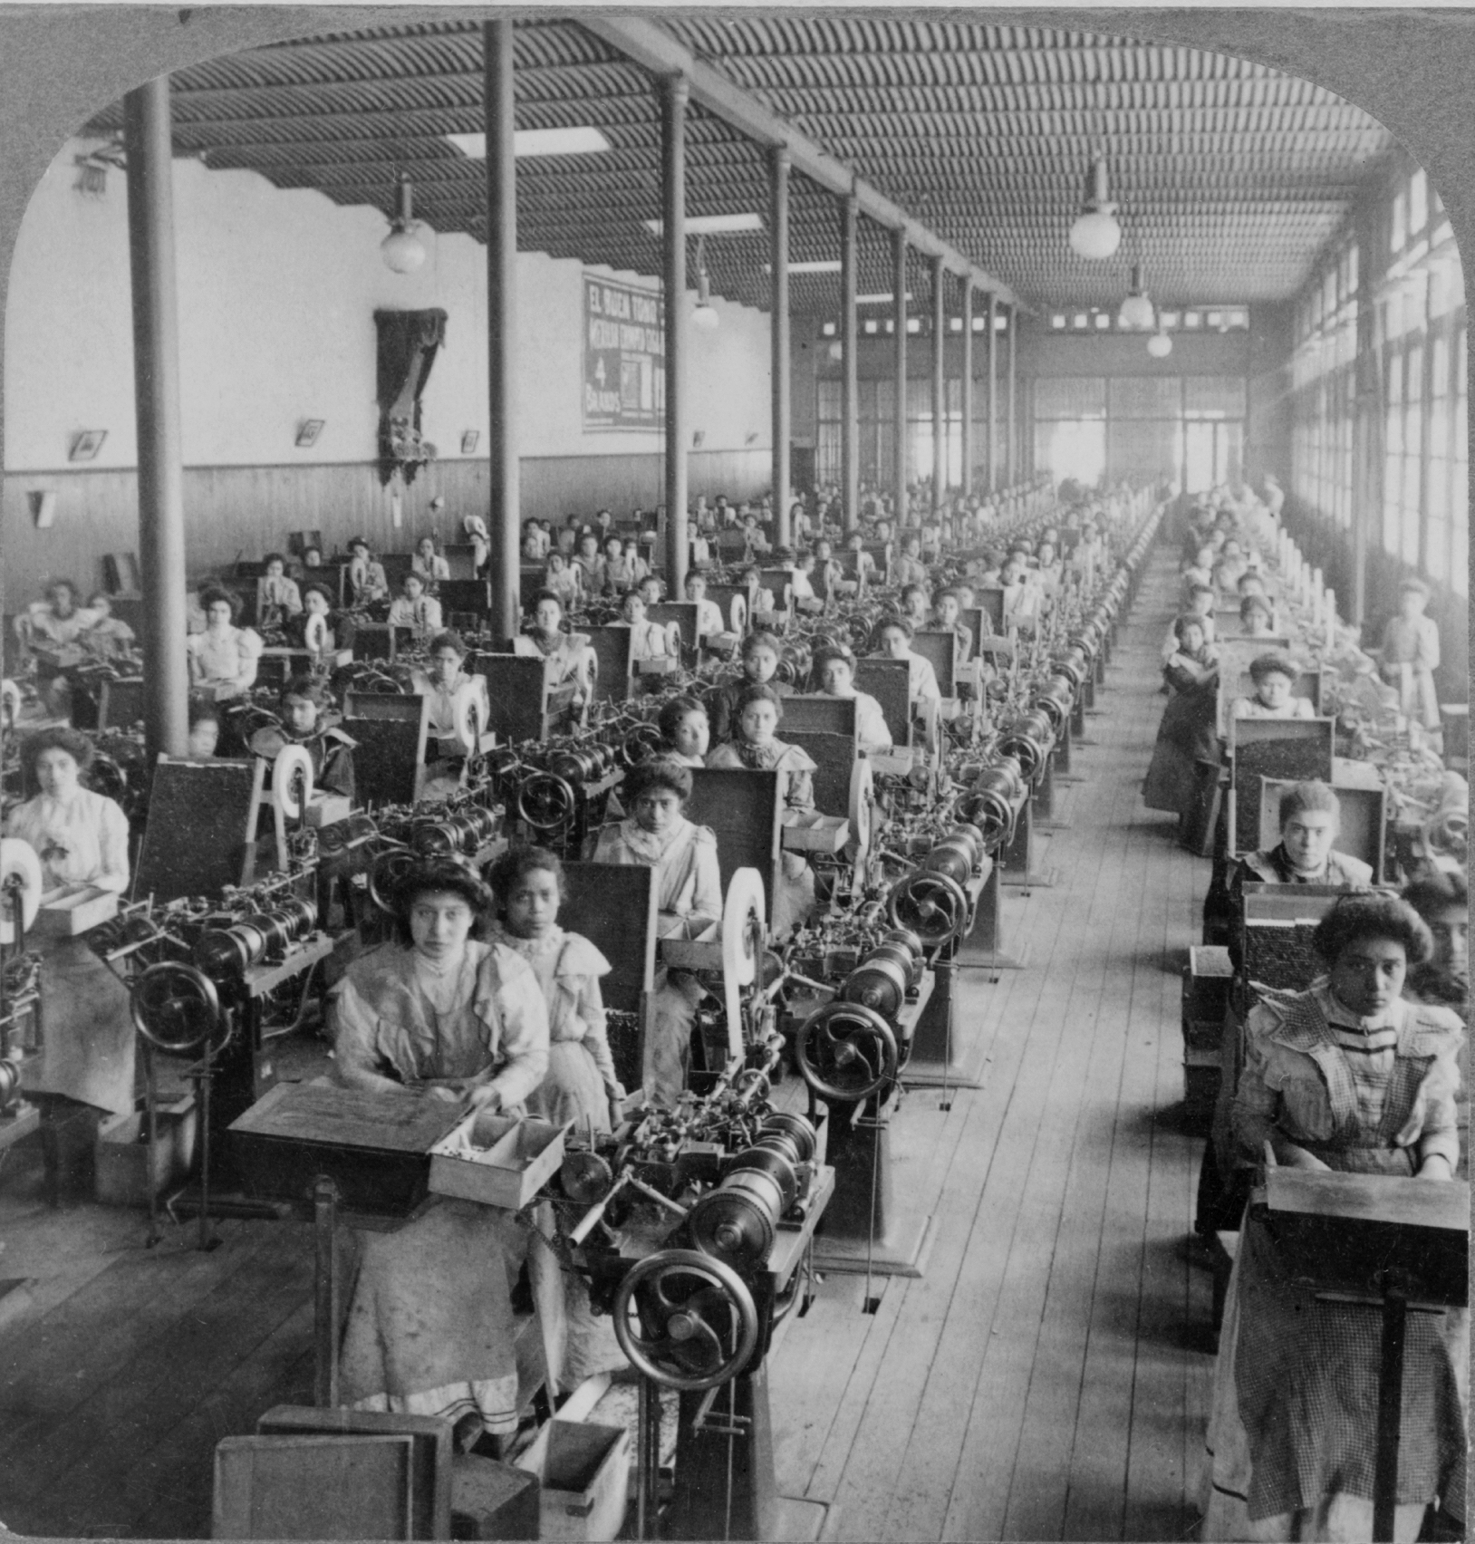

Source: photograph of 2,686 women working in the “El Buen Tono,” cigarette factory in Mexico City, Mexico, 1903

Factory Work & Life Gallery Walk / Scavenger Hunt

Directions: Use primary and secondary sources posted around the room to help you analyze the required documents on this checklist. Use the checklist to help you keep track. (NOTE: Each document can be used to help you fulfill more than one requirement). You need to analyze at least SIX documents by the end of the period.

_____ At least THREE sources representing a worker’s perspective

_____ At least ONE source representing a boss’s perspective

_____ At least ONE visual source

_____ At least ONE source that represents neither a worker nor a boss’s perspective

_____ At least THREE text-based sources

_____ At least ONE source dealing with child labor

How to read primary source documents:

- Observe the source information. That is, who created the document? When was the document made? What kind of document is it (ex: a journal entry, an official report, a photograph, etc.)? Where was the document made and/or published?

- Observe the content of the document. In other words, what is actually being said or represented in the document at the surface level? Is there an argument that someone is making? Is there a detailed description of an event? Are there people, objects, or actions being depicted?

- Analyze the document to deepen your understanding of the content. Here are some ways to do this (CAPP is an acronym that can help you remember how to analyze a document):

  - Context: What do you know about the time period in which the document was created? How might that further help you understand what is happening in the document?

  - Audience: For whom was the document created? Who might the author have intended to see the document, and how might that have affected the content in the document?

  - Purpose: Why was the document created, and how might that have affected the content in the document?

  - Point of view: What do you know about the background or beliefs of the person who created the document, and how might that have affected what is happening in the document and/or what is being presented in the document?

Factory Work & Life Gallery Walk / Scavenger Hunt

Directions: Use this worksheet to help you write a brief summary and analysis of each document you study. Use AT LEAST ONE part of CAPP to help your analysis for any primary source. Take note of evidence used to support interpretation for any secondary source.

Source info:

Summary of the Content:

[CAPP] Analysis:

Source info:

Summary of the Content [what have you read or seen?]:

[CAPP] Analysis:

Factory Work & Life Gallery Walk / Scavenger Hunt

Directions: Use this worksheet to help you write a brief summary and analysis of each document you study. Use AT LEAST ONE part of CAPP to help your analysis for any primary source. Take note of evidence used to support interpretation for any secondary source.

Source info:

Summary of the Content [what have you read or seen?]:

[CAPP] Analysis:

Source info:

Summary of the Content [what have you read or seen?]:

[CAPP] Analysis:

Factory Work & Life Gallery Walk / Scavenger Hunt

Directions: Use this worksheet to help you write a brief summary and analysis of each document you study. Use AT LEAST ONE part of CAPP to help your analysis for any primary source. Take note of evidence used to support interpretation for any secondary source.

Source info:

Summary of the Content [what have you read or seen?]:

[CAPP] Analysis:

Source info:

Summary of the Content [what have you read or seen?]:

[CAPP] Analysis:

Classes of Human Rights

Civil & Political Rights | Social & Economic Rights
Inspiration:  Historical Context: | Inspiration:  Historical Context:
Examples: | Examples:

Civil and political rights
Civil and political rights are a class of rights that protect individuals' freedom from unwarranted infringement by governments and private organizations, and ensure one's ability to participate in the civil and political life of the state without discrimination or repression.
Civil rights include the ensuring of peoples' physical integrity and safety; protection from discrimination on grounds such as physical or mental disability, gender, religion, race, national origin, age, or sexual orientation; and individual rights such as the freedoms of thought and conscience, speech and expression, religion, the press, and movement. (Some activist organizations include sexual orientation within the auspices of civil rights protections although there is continuing controversy over this issue in several countries)
Political rights include natural justice (procedural fairness) in law, such as the rights of the accused, including the right to a fair trial; due process; the right to seek redress or a legal remedy; and rights of participation in civil society and politics such as freedom of association, the right to assemble, the right to petition, and the right to vote.
Civil and political rights comprise the first portion of the Universal Declaration of Human Rights (with economic, social and cultural rights comprising the second portion). The theory of three generations of human rights considers this group of rights to be "first-generation rights"… [that is, these are rights which were developed as ideas during the Enlightenment, and implemented as law in Enlightenment-era social contracts, such as the United States Constitution (1787), and the French Declaration of the Rights of Man and Citizen (1789)].
Source: http://www.princeton.edu/~achaney/tmve/wiki100k/docs/Civil_and_political_rights.html [edited by Mr. Terry]

Economic, social, and cultural rights
Q: WHAT, IN GENERAL, DO WE MEAN BY “ECONOMIC, SOCIAL, AND CULTURAL RIGHTS”?

A: Human rights cover a wide range of aspects of human existence considered essential for life in dignity and security. Some of these relate to the freedom of the individual to act as she or he pleases as long as that action does not infringe on the rights and freedoms of others. These liberty-oriented rights are usually called civil and political rights and include freedom of speech and religion, the right to fair trial, and the right to be free from torture and arbitrary arrest. Other rights relate to conditions necessary to meet basic human needs, such as food, shelter, education, health care, and gainful employment. These are called economic, social and cultural rights.
Source: http://www.amnestyusa.org/pdfs/escr_qa.pdf

The origins of economic, social and cultural rights

Although economic, social and cultural rights are often described as “new” or “second-generation” rights, they have in fact been recognized for centuries. Both the French and American national rights declarations in the late 18th century included concepts such as “the pursuit of happiness” and “égalité et fraternité” (equality and brotherhood), and the rights to form trade unions, to collective bargaining and to safe labour conditions. The first global human rights institution, the International Labour Organization (ILO), has protected workers’ rights and a broader compass of human rights since 1919. Its constitution recognizes that “universal and lasting peace can be established only if it is based upon social justice”.

The Universal Declaration of Human Rights reiterated that “recognition of the inherent dignity and of the equal and inalienable rights of all members of the human family is the foundation of freedom, justice and peace in the world”. It went on to place a number of economic, social and cultural rights side by side with civil and political rights…

From 1948 to 1966 the international community struggled to agree an international covenant on human rights to turn this declaration into binding international law. Ultimately, the intense ideological cleavages of the time led to the adoption of two separate covenants, one on economic, social and cultural rights and the other on civil and political rights. Differing approaches were taken in each. While states are required to “respect and ensure” civil and political rights, they are required only to “achieve progressively the full realization of” economic, social and cultural rights. Nevertheless, as shown below, both contain immediate obligations and obligations to be achieved progressively.

The International Covenant on Economic, Social and Cultural Rights (ICESCR), adopted in 1966, enshrines the economic, social and cultural rights contained in the Universal Declaration of Human Rights in more developed and legally binding form. By the beginning of 2014, 161 states had become parties to the Covenant.
Source: https://www.amnesty.org/download/Documents/8000/pol340012014en.pdf

The Universal Declaration of Human Rights

PREAMBLE
Whereas recognition of the inherent dignity and of the equal and inalienable rights of all members of the human family is the foundation of freedom, justice and peace in the world,
Whereas disregard and contempt for human rights have resulted in barbarous acts which have outraged the conscience of mankind, and the advent of a world in which human beings shall enjoy freedom of speech and belief and freedom from fear and want has been proclaimed as the highest aspiration of the common people,
Whereas it is essential, if man is not to be compelled to have recourse, as a last resort, to rebellion against tyranny and oppression, that human rights should be protected by the rule of law,
Whereas it is essential to promote the development of friendly relations between nations,
Whereas the peoples of the United Nations have in the Charter reaffirmed their faith in fundamental human rights, in the dignity and worth of the human person and in the equal rights of men and women and have determined to promote social progress and better standards of life in larger freedom,
Whereas Member States have pledged themselves to achieve, in co­operation with the United Nations, the promotion of universal respect for and observance of human rights and fundamental freedoms,
Whereas a common understanding of these rights and freedoms is of the greatest importance for the full realization of this pledge,
Now, Therefore THE GENERAL ASSEMBLY proclaims THIS UNIVERSAL DECLARATION OF HUMAN RIGHTS as a common standard of achievement for all peoples and all nations, to the end that every individual and every organ of society, keeping this Declaration constantly in mind, shall strive by teaching and education to promote respect for these rights and freedoms and by progressive measures, national and international, to secure their universal and effective recognition and observance, both among the peoples of Member States themselves and among the peoples of territories under their jurisdiction.
Article 1.
All human beings are born free and equal in dignity and rights. They are endowed with reason and conscience and should act towards one another in a spirit of brotherhood.

Article 2.
Everyone is entitled to all the rights and freedoms set forth in this Declaration, without distinction of any kind, such as race, colour, sex, language, religion, political or other opinion, national or social origin, property, birth or other status. Furthermore, no distinction shall be made on the basis of the political, jurisdictional or international status of the country or territory to which a person belongs, whether it be independent, trust, non­self­governing or under any other limitation of sovereignty.

Article 3.
Everyone has the right to life, liberty and security of person.

Article 4.
No one shall be held in slavery or servitude; slavery and the slave trade shall be prohibited in all their forms.

Article 5.
No one shall be subjected to torture or to cruel, inhuman or degrading treatment or punishment.

Article 6.
Everyone has the right to recognition everywhere as a person before the law.

Article 7.
All are equal before the law and are entitled without any discrimination to equal protection of the law. All are entitled to equal protection against any discrimination in violation of this Declaration and against any incitement to such discrimination.

Article 8.
Everyone has the right to an effective remedy by the competent national tribunals for acts violating the fundamental rights granted him by the constitution or by law.

Article 9.
No one shall be subjected to arbitrary arrest, detention or exile.

Article 10.
Everyone is entitled in full equality to a fair and public hearing by an independent and impartial tribunal, in the determination of his rights and obligations and of any criminal charge against him.

Article 11.
(1) Everyone charged with a penal offence has the right to be presumed innocent until proved guilty according to law in a public trial at which he has had all the guarantees necessary for his defence.
(2) No one shall be held guilty of any penal offence on account of any act or omission which did not constitute a penal offence, under national or international law, at the time when it was committed. Nor shall a heavier penalty be imposed than the one that was applicable at the time the penal offence was committed.

Article 12.
No one shall be subjected to arbitrary interference with his privacy, family, home or correspondence, nor to attacks upon his honour and reputation. Everyone has the right to the protection of the law against such interference or attacks.

Article 13.
(1) Everyone has the right to freedom of movement and residence within the borders of each state.
(2) Everyone has the right to leave any country, including his own, and to return to his country.

Article 14.
(1) Everyone has the right to seek and to enjoy in other countries asylum from persecution.
(2) This right may not be invoked in the case of prosecutions genuinely arising from non­political crimes or from acts contrary to the purposes and principles of the United Nations.

Article 15.
(1) Everyone has the right to a nationality.
(2) No one shall be arbitrarily deprived of his nationality nor denied the right to change his nationality.

Article 16.
(1) Men and women of full age, without any limitation due to race, nationality or religion, have the right to marry and to found a family. They are entitled to equal rights as to marriage, during marriage and at its dissolution.
(2) Marriage shall be entered into only with the free and full consent of the intending spouses.
(3) The family is the natural and fundamental group unit of society and is entitled to protection by society and the State.

Article 17.
(1) Everyone has the right to own property alone as well as in association with others.
(2) No one shall be arbitrarily deprived of his property.

Article 18.
Everyone has the right to freedom of thought, conscience and religion; this right includes freedom to change his religion or belief, and freedom, either alone or in community with others and in public or private, to manifest his religion or belief in teaching, practice, worship and observance.

Article 19.
Everyone has the right to freedom of opinion and expression; this right includes freedom to hold opinions without interference and to seek, receive and impart information and ideas through any media and regardless of frontiers.

Article 20.
(1) Everyone has the right to freedom of peaceful assembly and association. (2) No one may be compelled to belong to an association.

Article 21.
(1) Everyone has the right to take part in the government of his country, directly or through freely chosen representatives.
(2) Everyone has the right of equal access to public service in his country.
(3) The will of the people shall be the basis of the authority of government; this will shall be expressed in periodic and genuine elections which shall be by universal and equal suffrage and shall be held by secret vote or by equivalent free voting procedures.

Article 22.
Everyone, as a member of society, has the right to social security and is entitled to realization, through national effort and international co­operation and in accordance with the organization and resources of each State, of the economic, social and cultural rights indispensable for his dignity and the free development of his personality.

Article 23.
(1) Everyone has the right to work, to free choice of employment, to just and favourable conditions of work and to protection against unemployment.
(2) Everyone, without any discrimination, has the right to equal pay for equal work.
(3) Everyone who works has the right to just and favourable remuneration ensuring for himself and his family an existence worthy of human dignity, and supplemented, if necessary, by other means of social protection.
(4) Everyone has the right to form and to join trade unions for the protection of his interests.

Article 24.
Everyone has the right to rest and leisure, including reasonable limitation of working hours and periodic holidays with pay.

Article 25.
(1) Everyone has the right to a standard of living adequate for the health and well­being of himself and of his family, including food, clothing, housing and medical care and necessary social services, and the right to security in the event of unemployment, sickness, disability, widowhood, old age or other lack of livelihood in circumstances beyond his control.
(2) Motherhood and childhood are entitled to special care and assistance. All children, whether born in or out of wedlock, shall enjoy the same social protection.

Article 26.
(1) Everyone has the right to education. Education shall be free, at least in the elementary and fundamental stages. Elementary education shall be compulsory. Technical and professional education shall be made generally available and higher education shall be equally accessible to all on the basis of merit.
(2) Education shall be directed to the full development of the human personality and to the strengthening of respect for human rights and fundamental freedoms. It shall promote understanding, tolerance and friendship among all nations, racial or religious groups, and shall further the activities of the United Nations for the maintenance of peace.
(3) Parents have a prior right to choose the kind of education that shall be given to their children.

Article 27.
(1) Everyone has the right freely to participate in the cultural life of the community, to enjoy the arts and to share in scientific advancement and its benefits.
(2) Everyone has the right to the protection of the moral and material interests resulting from any scientific, literary or artistic production of which he is the author.

Article 28.
Everyone is entitled to a social and international order in which the rights and freedoms set forth in this Declaration can be fully realized.

Article 29.
(1) Everyone has duties to the community in which alone the free and full development of his personality is possible.
(2) In the exercise of his rights and freedoms, everyone shall be subject only to such limitations as are determined by law solely for the purpose of securing due recognition and respect for the rights and freedoms of others and of meeting the just requirements of morality, public order and the general welfare in a democratic society.
(3) These rights and freedoms may in no case be exercised contrary to the purposes and principles of the United Nations.

Article 30.
Nothing in this Declaration may be interpreted as implying for any State, group or person any right to engage in any activity or to perform any act aimed at the destruction of any of the rights and freedoms set forth herein.

Source: Youth, Unions, and You: A Secondary Teacher’s Guide to Labour Studies for B.C. [British Columbia] Schools. B.C. Teachers’ Federation and the B.C. Federation of Labour. May 2001. https://bctf.ca/uploadedFiles/public/TeachingResources/YouthUnionsYou/SS9_L3.pdf

BACKGROUND

By the end of the 18th century, at the start of the Industrial Revolution, many British workers had seen the advantages of organizing into societies and brotherhoods: workers associations that could be called early trade unions. At the same time, the first legislation in Britain specifically directed at workers’ organizations was put in place. Those were the Combination Acts of 1799 and 1800. Their purpose was clearly stated: “to prevent unlawful combinations amongst journeymen to raise wages”. Journeyman is an old term for a day labourer; in other words, an ordinary worker. Any worker who joined an “unlawful combination”—a union—could be punished and the assets of the union could be confiscated. Obviously, the passing of those laws demonstrate that unions were being formed at the time, and those opposed to them controlled the government. So, why did workers form unions in the first place?

One of the main reasons, at that time of rapid industrialization, was to resist employers’ attempts to reduce the wages they paid their workers by forcing them to compete for work by undercutting each other in the wage market. For example, in 1801, the rules of the Society of Journeymen Millwrights stated:

“members of this society shall not work for any master except they receive 6 shillings 3d per day... any man going to work under the advanced wages shall be fined 9d per day, for the time worked under the said wages the money to be paid into the society’s funds, which is established for the support of superannuated and infirm mill-wrights”.

Sometimes groups of workers, took collective action and, despite the law, simply refused to work for low wages or under poor working conditions. This was first referred to as striking sail, the origin of the well-known term we still use for such an organized work stoppage. They and their supporters also developed other methods of struggle, including peaceful and militant protest, sabotage and political action.

Legally prohibited from forming unions, in 1811–1812 weavers from the midlands and north of England formed into secret militant groups to protest the unemployment and wage reductions caused by newly introduced textile technologies. Luddites, as they came to be called, would meet at night and travel the backroads between towns and villages. Their demands included reasonable rates of pay, better working conditions, and quality control of the products. Many factory owners complied, at least temporarily. Those who refused found their expensive machines wrecked. At the outset of their movement, the Luddites scrupulously avoided violence upon any person. However, incidents of violence began to occur on both sides of the conflict, and the government sent in 12 thousand British troops to put down the movement (more troops than they had fighting Napoleon in Spain). Many suspected Luddites were imprisoned or deported to Australia; quite a few were hanged, and their movement collapsed.

The Combination Acts were repealed in 1824, but following a rash of strikes, they were replaced with the Combination Act of 1825. It narrowly defined the rights of trade unions as meeting to bargain over wages and conditions. Striking and picketing could still be grounds for prosecution as a criminal conspiracy in restraint of trade. The legal system still viewed unionized workers as a threat to the established order. On one infamous occasion in 1834, six farm labourers from the quaintly named village of Tolpuddle, in Dorset, in southern England, were convicted of administering an illegal oath under an old law originally been intended to deal with naval mutinies. The convicts were deported to Tasmania. Known as the Tolpuddle Martyrs, they became important symbols for the union movement in the years that followed (there is even a Martyrs’ museum in Tolpuddle).

Some unionists realized that the existing laws were created by a British parliament and legal system dominated by rich landowners and newly rich industrial capitalists. In 1836, a group of politically active craftsmen in London formed the London Working Men’s Association and began a campaign to reform the system, to make it more representative of the middle class and workers. The following year, the association drew up a petition to the British Parliament setting out their six demands for change. The petition became known as the People’s Charter and the political movement called Chartism was born. Some Chartists believed gradual political reform achieved by peaceful petitioning was all that was required. Others had a more revolutionary viewpoint and argued for a nation- wide general strike that would unite all workers and force major changes upon the system. Although Chartism eventually collapsed as a movement, its influence would continue to be felt as most of its basic demands for political reforms were eventually put into place.

Not until the British government passed Trade Union Act of 1871 would British law finally recognize the right of workers to form unions; a similar law was passed by Canada’s Parliament a year later. However, even then, the right was still severely limited. For example, the Conspiracy and Protection of Property Act of 1875 outlawed picketing in Britain and also made it a crime for unionists to meet and plan an industrial campaign. Unions and their workers could also still be sued by their employers for job actions taken against them. It would take many more years of struggle for unions to gain further legal rights.

In many parts of the world, workers are still fighting for the most basic rights. Unions are also continuing to press for progressive laws in a wide range of areas that affect the whole of society. Social progress itself can be described as the combined system of laws and practices that alleviate human suffering. The labour movement has been in the forefront of the struggle for such legislation, right from its earliest days.

Source: Youth, Unions, and You: A Secondary Teacher’s Guide to Labour Studies for B.C. [British Columbia] Schools. B.C. Teachers’ Federation and the B.C. Federation of Labour. May 2001. https://bctf.ca/uploadedFiles/public/TeachingResources/YouthUnionsYou/SS9_L3.pdf

WEBQUEST: TEN CHOICES FOR WORKERS

Introduction

As the Industrial Revolution got under way in Britain, ordinary workers and their families faced low wages, terrible working conditions and oppressive laws. Without the right to form unions and without any real democratic rights, working class people were truly members of an oppressed group. What could they, and others in society who identified and sympathized with their situation, do about it? What options were open to them? Not all options were equally available. The diagram below sets out ten possible responses.

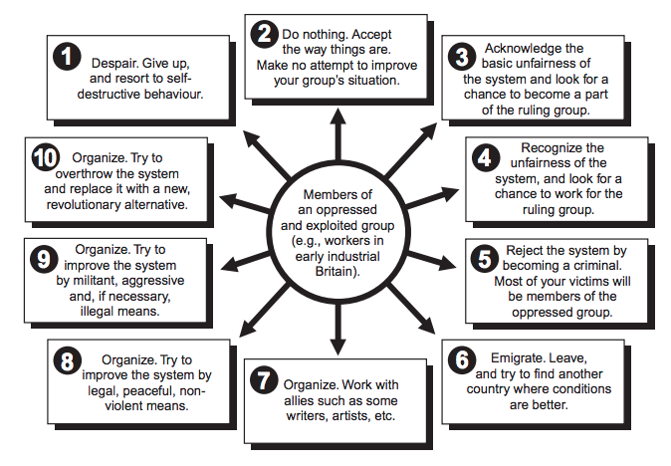

In this WebQuest, you will take the role of a worker from the period who decides to try to do something about the oppressive, exploitative conditions under which you are forced to live and work. You will be one of a group of workers who get together, organize yourselves and others into a union, and decide on a course of action.

It is 1815. You are a worker in a woollen mill in central England. The mill, owned by the Great Northern Fur Company, manufactures high quality blankets. The blankets are not sold in Britain. Rather, they are shipped to British North America, where they are one of the main trade items used by the Great Northern Fur Company in its trade with trappers. In return for valuable, premium fur pelts, the Company trades the blankets for many times more than their cost of production, making huge profits from the eventual sale of the furs.

Recently, the company introduced new machines into the mill, reduced the number of workers, cut the pay of the remaining workers, and started to hire young children at even lower wages to operate some of the new machines. The company also extended the working day to 13 hours. The two workers who approached the mill manager to complain about the worsening conditions were both fired.

THE TASK

Even though it is technically illegal for workers to form unions, you and nine other workers at the mill have decided to meet at your cottage to form a union that will organize the other workers at the mill and attempt to improve wages and conditions there. You are also concerned about the poverty and misery affecting ordinary people throughout your community. You hate the privileged position of the rich in your town. They seem to run everything and to have no concern for you and the rest of the common people. While you are all in agreement that something must be done to improve the way things are, you are not sure of the best direction to take.

Workers 1 & 2
You believe that the best way to move is to approach a very famous poet who lives in your town. He is known to be very sympathetic toward the plight of the poor, and, with his help, you intend to collect a series of drawings, paintings, sketches, cartoons, writings, etc. that illustrate the basic unfairness of life in Britain for the common people. You hope that they can be distributed and will raise people’s awareness. Your task is to locate such a collection of images and present 10 of the best ones, with explanations and sources, to the rest of the group.

Workers 3 & 4
You believe that it is useless to try to bargain with your employers under the present set of laws. You believe that until ordinary working people have democratic rights equal to those of the rich and powerful, the laws will not be changed. Eventually, a few years later, people known as Chartists will share your views. What are the basic demands you have to improve the system of government so that it becomes fairer, more representative of the common people? Why are they important? What methods could be used to achieve those changes? Your task is to bring that information back to the group.

Workers 5 & 6
You believe that waiting for a change in the law that could make your union technically legal will take too long. You think that you should go ahead and put immediate pressure on your employer by organizing and using your strength as workers. You believe that you may have to go on strike. You know that unions have been successful in similar situations. But you also know that union organizers have sometimes been severely punished—as would be the case of the Tolpuddle Martyrs a few years from now. Your task is to research any strike (past, present, or future) where workers have made important gains and report back to the group. You must also report back to the group on the case of the Tolpuddle Martyrs—as both a warning and an inspiration.

Workers 7 & 8
You believe that workers need to put more militant pressure on the capitalist mill owners and the government that supports them. You have secretly contacted a Luddite leader known by the pseudonym “King Ludd.” You try to discover why his approach to changing the system is worth trying. Your task is to interview that person and bring back the record of the interview to the rest of the group.

Workers 9 & 10
You are convinced that the present system cannot be improved by small changes. You see the rich and powerful in all parts of Britain continuing to oppress ordinary people. Unless there is a drastic transformation—a revolution—you believe that things will not really get any better. You have heard of the French Revolution and the American Revolution, which overthrew established systems and you wonder if British workers themselves, with the help of allied groups, could carry out a similar dramatic change. A few years from now, Karl Marx will propose just such an idea. What is the basis of such a revolution? Your task is to bring back to the group a rationale why all workers must start to organize and work toward a revolution.

PROCESS [this portion of the lesson modified by John Terry]

- Assign, or have students select their roles: Worker 1, Worker 2 . . . etc.
- Students begin to gather and organize the information they need, using the resources suggested below.
- Each pair should decide how they are going to present their information to the rest of the class, using Powerpoint or Google Slides. Presentation should include:
  - A title
  - General explanation of their option
  - Use of properly cited historical evidence
  - Works Cited or bibliography slide (depending on citation format teacher requires)
- After all five pairs have reported back to the main group, decide by vote which one or more of the options they will all work toward.
- Students share their work with the teacher and the rest of class.

RESOURCES [this set of resources also modified and updated from original lesson by John Terry]

You may wish to consult sources of information in addition to the sources of information listed here.

Workers 1 & 2
- William Wordsworth, “The Excursion”: https://sourcebooks.fordham.edu/mod/1814wordsworth.asp
- Charles Dickens, Hard Times: http://web.archive.org/web/19981206085048/http://pimacc.pima.edu/~gmcmillan/ht.html
- Elizabeth Gaskell, North and South: http://web.archive.org/web/19980116133239/http://pluto.clinch.edu/history/wciv2/civ2ref/north.htm
- Thomas Carlyle, Signs of the Times: https://sourcebooks.fordham.edu/mod/carlyle-times.asp
-
- Walter Crane: Images: www.iisg.nl/exhibitions/art/indexcrane.html
- Th. A. Steinlen: Images: www.iisg.nl/exhibitions/art/indexsteinlen.html
- Albert Hahn: Images: www.iisg.nl/exhibitions/art/indexhahn.html
- Poems for Workers: An Anthology: https://www.marxists.org/history/usa/pubs/lrlibrary/05-LRL-poem.pdf
- Paintings to search for: Ford Madox Brown, Work; Gustave Dore, Over London By Rail; Edgar Degas, Women Ironing; Gustave Caillebotte, The Floor Scrapers

Workers 3 & 4
- Modern History Sourcebook: Chartism: The People’s Petition, 1838: www.fordham.edu/halsall/mod/1838chartism.html
- The National Archives, “Chartists”: http://www.nationalarchives.gov.uk/education/politics/g7/
- British Library: http://www.bl.uk/learning/histcitizen/21cc/struggle/chartists1/introduction/historyofchartism.html
- The Victorian Web, “Chartism or The Chartist Movement”: http://www.victorianweb.org/history/hist3.html
- The National Archives, “The struggle for democracy: Getting the vote”: http://www.nationalarchives.gov.uk/pathways/citizenship/struggle_democracy/getting_vote.htm

Workers 5 & 6
- The Tolpuddle Martyrs Museum: www.tolpuddlemartyrs.org.uk/
- The Tolpuddle Martyrs: www.thedorsetpage.com/history/Tolpuddle_Martyrs/tolpuddle_martyrs.htm
- Radicalism & The Peterloo Massacre: https://sourcebooks.fordham.edu/mod/1819Peterloo.asp
- British Library, “Match Girls Strike”: http://www.bl.uk/learning/timeline/item106451.html
- BBC, “Setting the workers alight: the East End Match Girls’ Strike”: http://www.bbc.co.uk/legacies/work/england/london/article_1.shtml
- BBC, “London Dock Strike of 1889”: https://www.bbc.co.uk/programmes/p0288zcr

Workers 7 & 8
- The National Archives, “Luddites”: http://www.nationalarchives.gov.uk/education/politics/g3/
- Victorian Web, “The Luddites, 1811-1816”: http://www.victorianweb.org/history/riots/luddites.html
- University of Cambridge, “Rage against the machine”: https://www.cam.ac.uk/research/news/rage-against-the-machine
- Archive.org, “The Ballad of Ned Ludd”: https://archive.org/details/RTFM-Ludd
- Smithsonian, “What the Luddites Really Fought Against”: https://www.smithsonianmag.com/history/what-the-luddites-really-fought-against-264412/

Workers 9 & 10
- Encylopedia Brittanica, “Karl Marx”: https://www.britannica.com/biography/Karl-Marx
- Encyclopedia Brittanica, “Marxism”: https://www.britannica.com/topic/Marxism
- Victorian Web, “Victorian Socialism: An Introduction”: http://www.victorianweb.org/victorian/history/socialism/socialism.html
- Time, “A Brief History of Anarchism: The European Tradition”: http://content.time.com/time/world/article/0,8599,2040304,00.html
- Karl Marx, “Scientific Socialism”: https://sourcebooks.fordham.edu/mod/marx-summary.asp
- “History of the Paris Commune”: https://www.marxists.org/history/france/paris-commune/
- “An Interview with Karl Marx” by the Chicago Tribune: https://www.marxists.org/archive/marx/bio/media/marx/79_01_05.htm
- University of California, Berkeley, The Emma Goldman Papers: http://www.lib.berkeley.edu/goldman/
- Peter Kropotkin, “Anarchism: Its Philosophy and Ideal”: https://sourcebooks.fordham.edu/mod/1896kropotkin.asp

Student Name: _______________________________ Date: ____________

WEBQUEST: TEN CHOICES FOR WORKERS
Student Worksheet

Which worker are you? ______

Based on the description of your assignment, what brief title would you come up with to describe your assigned workers?

Directions: Use the space below to take notes on key information that you learn related to your assignment, through browsing the suggested online resources. Then, explain how your option can help address workers’ rights (i.e. human rights) issues in both the short-term and long-term. Be sure to make parenthetical citations in your notes below, so that you can trace your information back to the original sources.

WEBQUEST: TEN CHOICES FOR WORKERS
Student Worksheet

Directions: Use the space below to record additional notes on the other workers’ options, based on presentations from your classmates.

Title of presentation:  Key notes:  Short-term gains for rights:  Long-term gains for rights: | Title of presentation:  Key notes:  Short-term gains for rights:  Long-term gains for rights:
Title of presentation:  Key notes:  Short-term gains for rights:  Long-term gains for rights: | Title of presentation:  Key notes:  Short-term gains for rights:  Long-term gains for rights:

Tactics for Addressing Workers’ Issues

The following guide is separated into the following sections, which are explained in greater detail below.

- ORGANIZING – For workers who are currently not part of a collective organization, such as a labor union, organizing and forming a union would be a necessary first step to collective effort to bring about workplace change.

- COLLECTIVE BARGAINING / NEGOTIATION – For workers who are already part of a collective organization, such as a union, they can use the power of their collective to bring an employer to the bargaining table to negotiate better wages, conditions, or any other needs of workers who are employed by a given firm. This is an essential part of unionism that is protected by law in many countries, including the United States.

- LOBBYING FOR LEGAL REFORM – Unions often collect dues from workers in their union that can be used for political activity, such as lobbying. While lobbying, students have legal representatives meet with lawmakers to promote and ensure that laws are passed (or kept on the books) that protect the rights of working people.

- JOB ACTIONS & RESISTANCE– When more conventional methods, such as collective bargaining or lobbying, do not prove effective in ensuring the attainment or protection of workers’ rights, unions can use more action-based methods in an attempt to protect the rights of working people (ex: strikes, picketing, or boycotts).

1. ORGANIZING

Source: UE [United Electrical, Radio, and Machine Workers of America]. https://www.ueunion.org/org_steps.html [slightly modified by John Terry]

The Five Basic Steps to Organizing a Union

Although every workplace is different and the needs of workers vary, there are some basic steps involved in winning a union voice on the job. Here's how it happens ...

To begin organizing a union at your workplace there’s a simple starting point before going through the steps listed below: quietly talk to a few of your co-workers who you think may be interested in organizing.

This small group starts to privately discuss workplace issues, what is involved in organizing a union, and making plans to contact [a larger national or international union, if a workplace desires to be part of one]. When you’re ready, contact [the national or international union and a one of their representatives] will meet with the small group to answer your questions and help you develop a comprehensive organizing plan.

STEP 1: BUILD AN ORGANIZING COMMITTEE

Leaders are identified and an organizing committee representing all major departments and all shifts and reflecting the racial, ethnic and gender diversity in the workforce is established. Organizing committee training begins immediately. Committee members must be prepared to work hard to educate themselves and their co-workers about the union and to warn and educate co-workers about the impending management anti-union campaign. The organizing committee must be educated about workers’ right to organize and must understand [union] policies and principles of democracy and rank-and-file control.

Also at this step basic information about the workplace must be gathered including:
- workplace structure: departments, work areas, jobs, shifts
- employee information: name, address, phone, shift, job title, and department for each worker (employee list)
- employer information: other locations, parent company, product(s), customers, union history

STEP 2: ADOPT AN ISSUES PROGRAM

The committee develops a program of union demands (the improvements you are are organizing to achieve) and a strategy for the union election campaign. A plan for highlighting the issues program in the workplace is carried out through various organizing campaign activities.

STEP 3: SIGN-UP MAJORITY ON UNION CARDS

Your co-workers are asked to join [the national or international union] and support the union program by signing membership cards. The goal is to sign-up a sizable majority. This "card campaign" should proceed quickly once begun and is necessary to hold a union election.

STEP 4: WIN THE UNION ELECTION

The signed cards are used (and required) to petition the state or federal labor board to hold an election. It will take the labor board at least several weeks to determine who is eligible to vote and schedule the election. The union campaign must continue and intensify during the wait. If the union wins, the employer must recognize and bargain with the union. Winning a union election not only requires a strong, diverse organizing committee and a solid issues program, but there must also be a plan to fight the employer’s anti-union campaign.

STEP 5: NEGOTIATE A CONTRACT

The organizing campaign does not let up after an election victory. The real goal of the campaign, a union contract (the document the union and the employer negotiate and sign, covering everything from wages to how disputes will be handled), is still to be achieved. Workers must be mobilized to support the union’s contract demands (decided by you and your co-workers) and pressure the employer to meet them.

ORGANIZED! MAKE IT YOUR UNION!

[Depending on the labor union, there are varying degrees of democratic control at the workplace level, and bureaucratic control at the national or international level. Ultimately, workers still need to maintain large numbers as a collective at the workplace level for collective bargaining and other efforts to be effective. Unions at the workplace level also often benefit from the support – for legal representation, lobbying, or other financial or organizational support - of a larger organizational structure at the regional, national, or international level.]

2. COLLECTIVE BARGAINING (OR NEGOTIATING)

Source: Economic Policy Institute. “How today’s unions help working people: Giving workers the power to improve their jobs and unrig the economy.” https://www.epi.org/publication/how-todays-unions-help-working-people-giving-workers-the-power-to-improve-their-jobs-and-unrig-the-economy/

‘Collective bargaining’ is how working people gain a voice at work and the power to shape their working lives
Almost everyone has at one point felt unheard or powerless as an employee. Joining a union simply means that you and your colleagues have a say because you negotiate important elements of employment conditions together. That could mean securing wage increases, better access to health care, workplace safety enhancements, and more reasonable and predictable hours. Through collective bargaining negotiations, the union also works with management to develop a process for settling disputes that employees and their managers are unable to settle individually.
Once a collective bargaining agreement (CBA) is agreed to, union representatives work with employees and with management to make sure the rights and obligations spelled out in the agreement are honored. And they represent workers in high-stakes situations, such as when a safety violation has resulted in injury. By these means, collective bargaining gives workers a say in the terms of their employment, the security of knowing that there are specific processes for handling work-related grievances, and a path to solving problems.
To cover expenses for negotiating contracts, defending workers’ rights, resolving disputes, and providing support to members of the bargaining unit, unions collect dues.
The National Labor Relations Act (NLRA) of 1935 and amendments govern private-sector unions and collective bargaining. While states generally have no jurisdiction over private-sector unions, the NLRA as amended does allow states to enact certain laws that govern fees paid by workers in unionized private workplaces (discussed later in this report).
Nearly half (48.1 percent) of workers covered by a union contract are public-sector workers. Collective bargaining among federal workers is covered by the Federal Labor Relations Act of 1978 (FLRA). State laws (enacted from the late 1950s forward) govern state and local government employee unions. Each state has its own set of laws that govern collective bargaining for state and local public employees. Some states allow the full set of collective bargaining rights, others (approximately one-fifth) prohibit collective bargaining, and still others limit some activities, such as the right to strike or the right to collect dues automatically during payroll processing. About one in 10 states have no state law addressing collective bargaining rights in the public sector.
3. LOBBYING FOR LEGAL REFORM

Source: AFGE [American Federation of Government Employees]. “Lobbying Do’s and Don’ts” https://www.afge.org/take-action/afge-on-capitol-hill/lobbying-dos-and-donts/ [slightly modified by John Terry]

Your Right To Lobby Members of Congress
In general, federal employee’s have a statutory (legal) right to “individually or collectively” petition (lobby) Congress [as well as state and local legislators]. The law that covers this right [to lobby Congress] is 5 U.S.C. 7211.
“The right of employees, individually or collectively, to petition Congress or a Member of Congress, or to furnish information to either House of Congress, or to a committee or Member thereof, may not be interfered with or denied.”
Section 7211 of Title 5 of the Unites States Code
This right of federal employees to contact Members of Congress is undeniable to employees so long as they are not on duty time and not using government property or government resources.

Do's Checklist
- Do visit lawmakers while on leave
- Do write lawmakers using your own personal computer, stationary and postage or union bought stationary and postage
- Do distribute copies of [your union’s] flyers, action faxes, sample letters and other information to [your union’s] members before or after work “off the clock” and at local union meetings.
  - Do invite [your union’s] members and potential members to “off the clock” meetings at the worksite in a break room or if at a DoD location to an offsite location. Ask participants to use union bought paper and pens to write a brief letter or fill out a fax to their member of Congress during the meeting. You can also pass around a personal or union cell-phone to permit members to call lawmakers right then.
  - Do, if a union official on official time and under the provisions of a collective bargaining agreement which allows such conduct, contact lawmakers using government telephones provided to the union.
  - Do under a collective bargaining agreement or based on past practices, use an agency's mail delivery, e-mail, inter-office phone or other communication system to advise employees of:
- [your union]'s position on certain legislation
- the contents of specific legislative proposals
- when Congress may mark-up a legislative proposal
- when Congress may vote on a certain issue
- when [your union] is to testify on a certain legislative issue

Don'ts Checklist
- Don't write letters to or phone members of Congress when on duty time and using an agency's phone, paper or other equipment.
- Don't use the Agency's e-mail, or other communication systems to circulate any material asking an AFGE member or potential member to write, call or email their Senators or Representative on legislative initiatives.
- Don't use official time and any equipment belonging to an agency to present the views of the union to Members of Congress unless this is a past practice or is provided for in a collective bargaining agreement.

4. JOB ACTIONS & RESISTANCE
Source: International Brotherhood of Teamsters. “Definitions for Common Labor Terms.” https://teamster.org/content/definitions-common-labor-terms#j

Job Action: A concerted activity by employees designed to put pressure on the employer without resorting to a strike. Examples include: wearing T-shirts, buttons, or hats with union slogans, holding parking lot meetings, collective refusal of voluntary overtime, reporting to work in a group, petition signing, jamming phone lines, etc.

Work-to-Rule: A tactic in which workers agree to strictly follow all work rules, even those which are usually not followed. The result is that less work is performed or that the employer is forced to deal with more paperwork, putting pressure on the employer to settle workers' complaints. Some, but not all, work-to-rule campaigns are considered slowdowns, and may violate no-strike clauses in particular contracts or public sector laws.

Consumer Picketing: Picketing of a retail establishment that is legal if directed toward getting consumers not to buy a particular product of a supplier or of a producer with whom a labor dispute exists. Such picketing is illegal if it is aimed at getting customers to stop shopping at the store or at other parties, such as store employees or delivery to prevent personnel from crossing the picket line.

Informational Picketing: Picketing done with the express intent not to cause a work stoppage, but to publicize either the existence of a labor dispute or information concerning the dispute. Picketing done with the express intent not to cause a work stoppage but to publicize either the existence of a labor dispute or information concerning the dispute.

Boycott: A concerted refusal to work for, purchase from, or handle the products of an employer. Where the action is directed against the employer directly involved in the labor dispute, it is termed a primary boycott. In a secondary boycott, the action is directed against a neutral employer in an attempt to get him/her to stop doing business with the company with which the union is having a dispute. Secondary boycotts are illegal under the Taft Hartley Act.

Mass Picketing: Patrolling by large numbers of people in close formation, often preventing access to company premises.

Economic Strike: A work stoppage by employees seeking economic benefits such as wages, hours, or other working conditions. This differs from a strike which is called solely to protect unfair labor practices.

Strike Force: A group of volunteer members who have agreed to help picket or leaflet in support of an organizing drive, strike, or other campaign which the local has initiated.

Sitdown Strike: A work action which is currently illegal in which strikers refuse to leave the employer’s premises.

General Strike: A strike by all or most organized workers in a community or nation.

Source: National Labor Relations Board. https://www.nlrb.gov/rights-we-protect/whats-law/employees/i-am-not-represented-union/strikes-pickets-and-protest

Strikes, Pickets and Protest
All employees - union or not - have the right to participate in a protected strike, picket or protest.
You have a right to strike, picket, and protest regarding work-related issues, but there are limitations and qualifications on the exercise of that right. Your right to engage in these activities depends on the object or purpose of the action, on its timing, or on the conduct of those involved. (For more about unprotected strikes, see the "I am represented by a union" and "union rights and responsibilities" sections of this app.) Violence or other serious misconduct, such as destruction of property, is not protected.

Source: National Labor Relations Board. https://www.nlrb.gov/rights-we-protect/whats-law/employees/i-am-not-represented-union/strikes-pickets-and-protest

The Right to Strike
Section 7 of the National Labor Relations Act states in part, “Employees shall have the right. . . to engage in other concerted activities for the purpose of collective bargaining or other mutual aid or protection.” Strikes are included among the concerted activities protected for employees by this section. Section 13 also concerns the right to strike. It reads as follows:
Nothing in this Act, except as specifically provided for herein, shall be construed so as either to interfere with or impede or diminish in any way the right to strike, or to affect the limitations or qualifications on that right.
It is clear from a reading of these two provisions that: the law not only guarantees the right of employees to strike, but also places limitations and qualifications on the exercise of that right…
For more information please see the Basic Guide to the National Labor Relations Act.

Student Name: _______________________________ Date: ____________

STUDENT RESEARCH: CONTEMPORARY LABOR ISSUES
Student Worksheet

PART 1: RESEARCH

Directions: It is your task to identify a present-day labor issue, in which workers’ rights (i.e. human rights) are being violated. Use the space below to discuss the issue you identified and be sure to address all of the following:
- Where is the issue taking place, and how long has it been happening?
- Who are the workers that are affected?
- Why is this particular labor issue happening? (In other words, what might other actors, such as employers, have to gain from such a situation?)
- How is the issue a human rights issue? (refer to the UDHR to explain)
- Make sure you have full citations for your work (you should be consulting at least three quality sources)

PART 2: STRATEGY

Directions: It is your task to develop a strategy in response to the present-day labor issue you took notes on above. Use the space below to discuss the issue you identified and be sure to address all of the following:
- Which tactics will be most appropriate for addressing the issue? (see “Tactics for Addressing Workers’ Issues” handout)
- Evaluate all possible options in terms of how effective they will be in achieving workers’ rights in the short-term and in the long-term.

After you have completed your research and developed an effective strategy for dealing with the labor issue, prepare a presentation for an upcoming, in-class “Labor Summit.”

iStudy for Success! “Active Reading.” Penn State University. http://tutorials.istudy.psu.edu/activereading/
“Active Reading Strategies.” The McGraw Center for Teaching & Learning. www.princeton.edu/mcgraw

