Human Rights Education Curriculum Integration Guide Project

LESSON TITLE: Are Human Rights Universal?

RECOMMENDED GRADE LEVEL(S) FOR IMPLEMENTATION: 10-12th

INSTRUCTIONAL TIME OR CLASS SESSIONS REQUIRED: 2 Class Sessions of 80 Minutes Each (Block Periods)

LESSON AUTHOR: Marco DiMarcello

AUTHOR AFFILIATION: Hunterdon Central Regional High School, Flemington NJ

BRIEF DESCRIPTIVE SUMMARY OF LESSON:

Using hypothetical examples, students will discuss the concept of universal human rights and their personal thoughts and opinions on the issues. Students will be asked to read or listen to various news articles about the topics, conduct their own research, and prepare notes for a discussion. The purpose is to use current and personal examples in order to engage students in the discussion of human rights.

NJ CORE CURRICULUM STANDARD ADDRESSED IN LESSON:

- 6.1.12.D.14.e Evaluate the role of religion on cultural and social mores, public opinion, and political decisions.
- 6.2.12.A.5.e Assess the progress of human and civil rights around the world since the 1948 U.N. Declaration of Human Rights.
- 6.1.12.D.14.f Determine the influence of multicultural beliefs, products (i.e., art, food, music, and literature), and practices in shaping contemporary American culture.
- 6.1.12.D.16.a Analyze the impact of American culture on other world cultures from multiple perspectives.
- 6.2.12.D.4.j Analyze how the social, economic, and political roles of women were transformed during this time period.
- 6.2.12.D.5.d Analyze how feminist movements and social conditions have affected the lives of women in different parts of the world, and evaluate women’s progress toward social equality, economic equality, and political equality in various countries.

CORE CURRICULUM STANDARDS REFERENCED IN LESSON:

1. CCSS.ELA-LITERACY.SL.9-10.1. A Come to discussions prepared, having read and researched material under study; explicitly draw on that preparation by referring to evidence from texts and other research on the topic or issue to stimulate a thoughtful, well-reasoned exchange of ideas.

2. CCSS.ELA-LITERACY.SL.9-10.1.C Propel conversations by posing and responding to questions that relate the current discussion to broader themes or larger ideas; actively incorporate others into the discussion; and clarify, verify, or challenge ideas and conclusions.

3. CCSS.ELA-LITERACY.SL.9-10.1.D Respond thoughtfully to diverse perspectives, summarize points of agreement and disagreement, and, when warranted, qualify or justify their own views and understanding and make new connections in light of the evidence and reasoning presented.

4. CCSS.ELA-LITERACY.RH.11-12.7
Integrate and evaluate multiple sources of information presented in diverse formats and media (e.g., visually, quantitatively, as well as in words) in order to address a question or solve a problem.

LITERACY DEVELOPMENT CONNECTIONS IN LESSON:

- To read and listen to news publications about human rights issues around the world.

- Read and incorporate evidence from human rights documents in the discussion.

LESSON GOALS/OBJECTIVES—Students will be able to:

- Understand and explain the difference between cultural relativism and ethnocentrism in relation to universal human rights.

- Discuss and evaluate various human rights scenarios in order to refine their understanding of the universality of human rights.

- Apply outside research, examples, and human rights documents to their assessment of the scenarios.

LESSON METHOLODOGY AND PROCEDURES:

- Pose the focus question of the unit: Are human rights universal? You could start with the example of education. Is education something that should be offered universally to everyone? Primary education only? What about secondary and university level? You can use education or any other example you want to help students understand what is meant by universal. Now have them react to the idea of universality by providing their own arguments and examples.
- You can have students do a quick writing activity with the focus question. You can add additional questions to the focus question to help them start to write: What happens when cultural practices seem to violate human rights? Is right and wrong a function of perspective or is it something that is universal? An example might help prompt students to write a little: underage drinking in some cultures, education, health care, gun control, gender quality, etc. Have students share out their responses.
- Briefly review and define the following terms with your students: ethnocentrism and cultural relativism. Use examples to help illustrate the definition and have student brainstorm the positive and negative aspects of each term. For example, being a staunch cultural relativist allows for greater understanding and acceptance but might also indirectly approve of behaviors and actions that might be seen as immoral. You can locate several YouTube videos that quickly illustrate simple definitions and examples. (See attached handout-- Student Note-taking Sheet—Ethnocentrism vs. Cultural Relativism.)
- Hand out the worksheet Discussion Preparation With Scenarios. Students should either read or listen to the articles that are linked to each scenario. Students should mark an X on the line where they stand on the issue and use the space below each example to record notes, facts, and ideas they would like to use in the discussion.
- Depending upon the amount of time you would like to spend on the discussion you can save time by just discussing the scenarios without looking at the articles. Another option would be to just listen to the podcast instead of reading the texts. This might be helpful for those who have difficulty reading or if students have challenges with understanding written English. You can do just one or two of the scenarios if you want to condense the lesson in the interest of time.
- Along with the lesson are two tools for carrying out a class discussion. The “leader” of the discussion can either be the teacher or a student. This student is charged with moderating the discussion, posing questions, calling on individuals, moving through the scenarios, and maintaining decorum. The “tracker” records the participation by each of the student and classifies the comments and questions of the students. There is a completed sample provided with this lesson.
- If you want students to use more evidence, students can locate additional sources and be required to utilize that information in the discussion. The quick writing activity, notes, and evidence gathering will take at least one class period.
- On day two review each of the scenarios as a class discussion. Have students share their evidence and thoughts on each of the scenarios. This can be done as a large class discussion or a fishbowl technique can be used for each scenario with the outer group recording and evaluating the inner group. A discussion tracking tool, sample, and rubric are provided (see attached files).
- At the end if there is time, you can revisit the initial question: Are rights universal? Encourage students to draw upon the discussion and make connections to the scenarios or their own lives and experiences.

ASSESSMENT OF STUDENT PERFORMANCE:

- The discussion can be graded and scored. A rubric for tracking and self-evaluating is provided, along with a sample tracking tool. See items 1, 4 and 5 under Teacher Designed Materials in the Learning Resources Section of this Lesson Plan.

LEARNING RESOURCES:

- “Polygamy May Seem Like A Man's Dream, But Kenyan Women Are Not Happy.” Tell Me More: NPR. 26 March 2014. Web. 12 December 2015. <http://www.npr.org/2014/03/26/294804072/polygamy-may-seem-like-a-mans-dream-but-kenyan-women-are-not-happy>.

- “The Joy of Leaving an Arranged Marriage- And the Cost.” Weekend Edition Sunday: NPR. 16 June 2014. Web. 12 December 2015. <http://www.npr.org/2014/06/15/322004182/how-one-woman-left-an-arranged-marriage-and-what-it-cost-her>.

- Beardsley, Eleanor. “France's Burqa Ban Adds To Anti-Muslim Climate” Morning Edition: NPR. 11 March 2011. Web. 12 December 2015. <http://www.npr.org/2011/04/11/135305409/frances-burqa-ban-adds-to-anti-muslim-climate>.

- Fadel, Leila. “Egyptian Doctor Found Guilty Of Female Genital Mutilation Isn't In Jail” Morning Edition: NPR. 11 December 2015. Web. 12 December 2015. <http://www.npr.org/sections/goatsandsoda/2015/12/11/459238614/why-the-egyptian-doctor-found-guilty-of-female-genital-mutilation-isnt-in-jail>.

- “Bolivia Makes Child Labor Legal, In An Attempt To Make It Safer” Morning Edition: NPR. 30 July 2014. Web. 12 December 2015. <http://www.npr.org/2014/07/30/336361778/bolivia-makes-child-labor-legal-in-an-attempt-to-make-it-safer>.

- Universal Declaration of Human Rights (UDHR)- Articles 2, 16, 25, & 26
http://www.un.org/en/universal-declaration-human-rights/

- Convention on the Rights of the Child- Article 32 http://www.ohchr.org/en/professionalinterest/pages/crc.aspx

- African Charter on the Rights and Welfare of the Child- Article 31 https://www1.umn.edu/humanrts/africa/afchild.htm

- Convention on the Elimination of all Forms of Discrimination Against Women(CEDAW)- Articles 1, 5, & 16 http://www.un.org/womenwatch/daw/cedaw/text/econvention.htm#article14

- “Who Decides if You’re too Young to Marry?” All Things Considered: NPR. 5 April 2016. Web. 20 May 2016. < http://www.npr.org/2016/04/05/473106012/who-decides-if-youre-too-young-to-marry>

- Cole, Diane. “Children Get Married In The U.S., Too: #15Girls” Stories of Life in Changing World: NPR. 28 October 2015. Web. 20 May 2016. <http://www.npr.org/sections/goatsandsoda/2015/10/28/452540839/children-get-married-in-the-u-s-too-15girls>

Teacher Designed Materials Used in the Lesson

- Discussion Rubric (Used with permission of Jessica Long, English Department, Hunterdon Central Regional HS)
- Teacher Resource—Ethnocentrism vs. Cultural Relativism
- Student Note-taking Sheet—Ethnocentrism vs. Cultural Relativism
- Discussion Tracking Tool
- Discussion Tracking Tool—with sample responses
- Discussion Worksheet with Scenarios

EXTENSION RESOURCES:

- “Competing Visions of Human Rights.” Watson Institute for International Studies, Brown University. Choices for the 21st Century Education Program. 2012. <www.choices.edu>. This unit builds upon the discussion of human rights in a global context.

MODIFICATIONS OR ADAPTATIONS OF THE LESSON FOR DIFFERENTIATED LEARNERS:

- Many of the sources used are also podcasts. This would be helpful to use with students who might have difficulty processing news articles.

- You can assign groups to just one of the scenarios to research and discuss in small groups.

- The research component can be removed if you choose to have students discuss their ideas without relying on textual evidence. The activity would function more as an ice-breaker for understanding the complexity of human rights and sparking an interest in the overall topic.

- Add different topics that might be more relevant or interesting depending upon student abilities, interests and backgrounds.

Name:
Essential Question: Are Human Rights Universal?

Instructions:

- Use the source below to help you formulate your thoughts/reactions to the scenarios below.
- Listen to or read the news article using the link provided. Record notes below each scenario from the news article that you would like to use when discussion the issue.
- Make a mark on the line indicating the degree to which you agree or don’t agree with the practice. For example if you are fine with the practice of polygamy and do not see it as a violation of women’s rights you would make a mark on the line closer to the cultural relativist side. If see polygamy as wrong and potentially harmful to women you would mark the line closer to ethnocentrism.
- Locate 1 additional source for each scenario and provide additional notes in the table located below each scenario.
- Use the following international human rights documents in some of your arguments. Note the specific articles that are referenced. After each article you will see a bracket indicating the issue the article addresses. This should help you match it with the particular scenario.
- Universal Declaration of Human Rights (UDHR)- Articles 2 (discrimination), 16 (marriage), 25 & 26 (adequate living standards)
  - http://www.un.org/en/universal-declaration-human-rights/

- Convention on the Rights of the Child(CRC)- Article 32 (Conditions for the employment of children)
  - http://www.ohchr.org/en/professionalinterest/pages/crc.aspx

- African Charter on the Rights and Welfare of the Child- Article 31(responsibilities of the child with the inclusion of regional values)
  - https://www1.umn.edu/humanrts/africa/afchild.htm

- Convention on the Elimination of all Forms of Discrimination Against Women(CEDAW)- Articles 1 (discrimination), 5 (equality vs cultural practices), & 16 (marriage)
  - http://www.un.org/womenwatch/daw/cedaw/text/econvention.htm#article14

- Feel free to do additional research for potential arguments.

NAME:

- Teenage Marriage: Should teenagers be allowed to get married?

“Who Decides if You’re too Young to Marry?” All Things Considered: NPR. 5 April 2016. Web. 20 May 2016. < http://www.npr.org/2016/04/05/473106012/who-decides-if-youre-too-young-to-marry>

Cole, Diane. “Children Get Married In The U.S., Too: #15Girls” Stories of Life in a Changing World: NPR. 28 October 2015. Web. 20 May 2016. <http://www.npr.org/sections/goatsandsoda/2015/10/28/452540839/children-get-married-in-the-u-s-too-15girls>

Cultural Ethnocentrism
Relativism

Your Additional Source:

Human Rights Document and Article you will use (write out excerpt you will use):

Notes for discussion:

Source/link | Quote/fact/data | Interpretation
Cole | Sample: Between 1995 and 2012 in NEW JERSEY -“178 of the newlyweds (the data did not identify gender or other details only the ages) were between ages 10 and 15.”  ADD MORE | Surprising how young they were and in the very state I live in. Seems too young in my opinion to make such an important decision.

- Polygamy: One husband, many wives. Practiced by many traditional cultures.

“Polygamy May Seem Like A Man's Dream, But Kenyan Women Are Not Happy.” Tell Me More: NPR. 26 March 2014. Web. 12 December 2015. <http://www.npr.org/2014/03/26/294804072/polygamy-may-seem-like-a-mans-dream-but-kenyan-women-are-not-happy>.

Cultural Ethnocentrism
Relativism

Your Additional Source:

Human Rights Document and Article you will use (write out excerpt you will use):

Notes for discussion:

Source/link | Quote/fact/data | Interpretation

- Women: Arranged Marriages

“The Joy of Leaving an Arranged Marriage- And the Cost.” Weekend Edition Sunday: NPR. 16 June 2014. Web. 12 December 2015. <http://www.npr.org/2014/06/15/322004182/how-one-woman-left-an-arranged-marriage-and-what-it-cost-her>.

Cultural Ethnocentrism
Relativism

Your Additional Source:

Human Rights Document and Article you will use (write out excerpt you will use):

Notes for discussion:

Source/link | Quote/fact/data | Interpretation

- Women’s Rights in Saudi Arabia

“Boxed In: Women and Saudi Arabia’s Male Guardianship System.” Human Rights Watch. 16 July 2016. Web. 12 September 2016. < https://www.hrw.org/report/2016/07/16/boxed/women-and-saudi-arabias-male-guardianship-system.>

“Nine things women can’t do in Saudi Arabia.” The Week. 18 July 2016. Web. 12 September 2016. <http://www.theweek.co.uk/60339/nine-things-women-cant-do-in-saudi-arabia>..

Almashabi, Deena. “Prince Says Saudi Arabia Not Yet Ready to Allow Women to Drive.” Bloomberg. 16 April 2016. Web. 12 September 2016. <http://www.bloomberg.com/news/articles/2016-04-26/prince-says-saudi-arabia-not-yet-ready-to-allow-women-to-drive>

Cultural Ethnocentrism
Relativism

Your Additional Source:

Human Rights Document and Article you will use (write out excerpt you will use):

Notes for discussion:

Source/link | Quote/fact/data | Interpretation

- “Cleansing” or Female Genital Mutilation (FGM).

Fadel, Leila. “Egyptian Doctor Found Guilty Of Female Genital Mutilation Isn't In Jail” Morning Edition: NPR. 11 December 2015. Web. 12 December 2015. <http://www.npr.org/sections/goatsandsoda/2015/12/11/459238614/why-the-egyptian-doctor-found-guilty-of-female-genital-mutilation-isnt-in-jail>.

Cultural Ethnocentrism
Relativism

Your Additional Source:

Human Rights Document and Article you will use (write out excerpt you will use):

Notes for discussion:

Source/link | Quote/fact/data | Interpretation

- Child labor. Economic conditions require very young children to work in order to support their families at the cost of their education.

“Bolivia Makes Child Labor Legal, In An Attempt To Make It Safer” Morning Edition: NPR. 30 July 2014. Web. 12 December 2015. <http://www.npr.org/2014/07/30/336361778/bolivia-makes-child-labor-legal-in-an-attempt-to-make-it-safer>.

Cultural Ethnocentrism
Relativism

Your Additional Source:

Human Rights Document and Article you will use (write out excerpt you will use):

Notes for discussion:

Source/link | Quote/fact/data | Interpretation

For Teachers - Ethnocentrism vs. Cultural Relativism

Ethnocentrism: is judging another culture solely by the values and standards of one's own culture.

Ethnocentric individuals judge other groups relative to their own ethnic group or culture, especially with concern forlanguage, behavior, customs, and religion. These ethnic distinctions and subdivisions serve to define each ethnicity's unique cultural identity.^{[2]} Ethnocentrism may be overt or subtle, and while it is considered a natural proclivity of human psychology, it has developed a generally negative connotation. (Wikipedia)

Examples: Language, customs, food, flag, anthems, groups (Irish-American clubs), etc. Have them brainstorm for more.

Reactions: immigrations laws, reaction to ethnic foods, hearing groups speak another language, signage in another language, job competition, etc. Again, brainstorm other ideas.

Advantages & Disadvantages

Cohesion, belonging, traditions, identity, uniqueness, pride etc.
Vs.
Exclusion, fear, hyper-nationalism, intolerance, violence, genocide

Cultural Relativism: is the principle that an individual person's beliefs and activities should be understood by others in terms of that individual's own culture. (https://www.boundless.com/sociology/textbooks/boundless-sociology-textbook/culture-3/culture-and-society-29/ethnocentrism-and-cultural-relativism-186-4770/)

Examples: Trying different types of food, going to other cultural festivals, understanding varying viewpoints, etc.

Advantages & Disadvantages

Toleration, acceptance, inclusion, cultural borrowing etc
Vs.
Acceptance of questionable practices (see scenarios or other examples students can think of like not allowing women the right to drive is some countries), lack of universal understanding of rights, moral clarity in terms of what is right and wrong, etc.

Ethnocentrism vs. Cultural Relativism

Ethnocentrism:

Examples:

Advantages & Disadvantages

Cultural Relativism:

Examples:

Advantages & Disadvantages

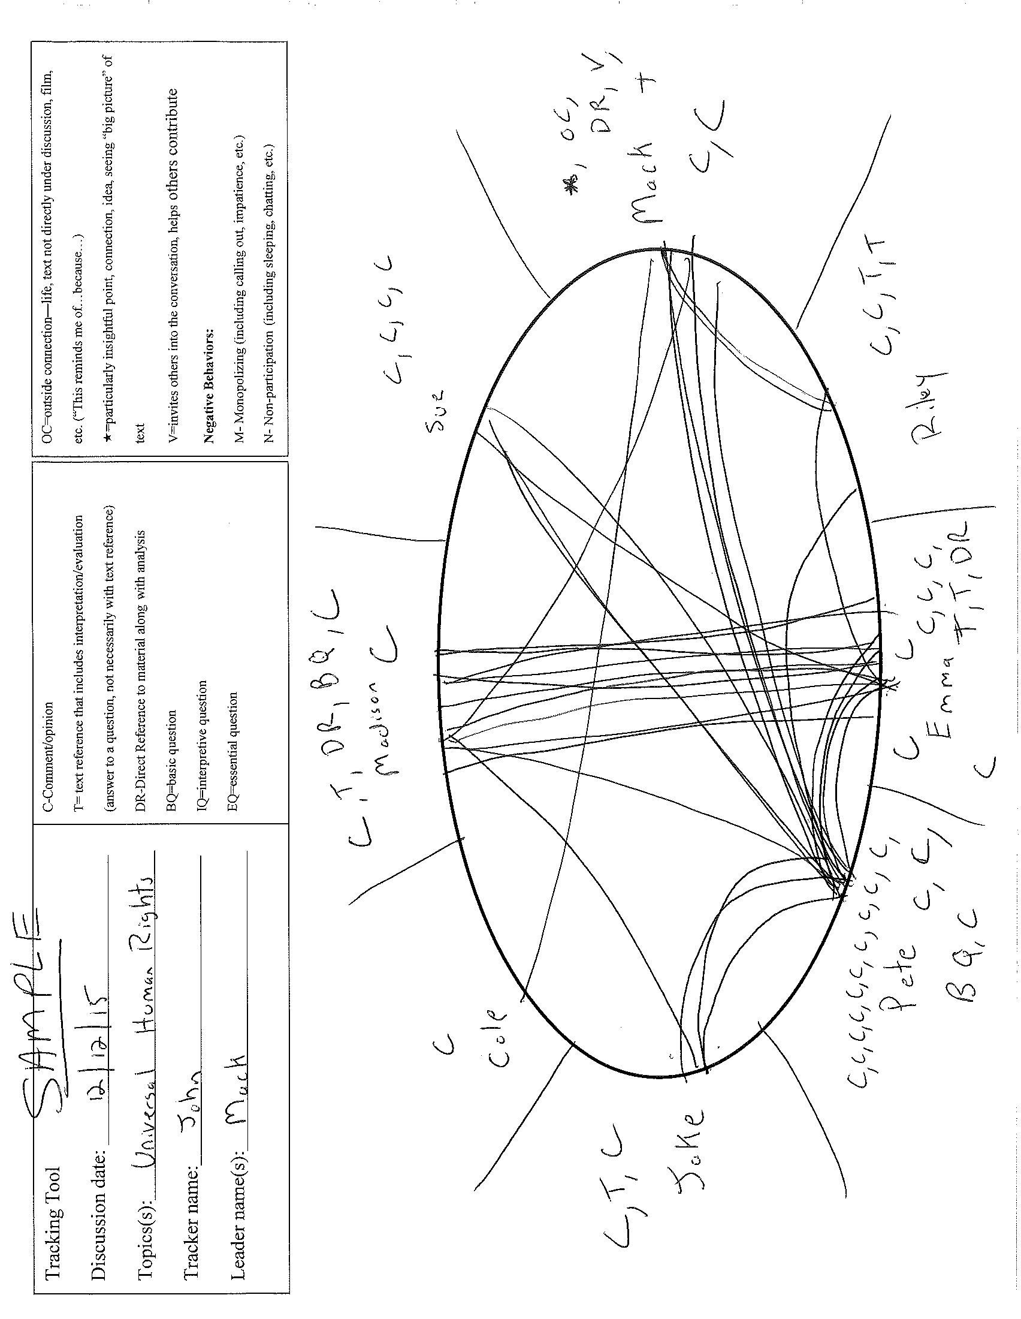
C-Comment/opinion
T= text reference that includes interpretation/evaluation (answer to a question, not necessarily with text reference)
DR-Direct Reference to material along with analysis
BQ=basic question
IQ=interpretive question
EQ=essential question

OC=outside connection—life, text not directly under discussion, film, etc. (“This reminds me of…because…)
=particularly insightful point, connection, idea, seeing “big picture” of text
V=invites others into the conversation, helps others contribute
Negative Behaviors:
M- Monopolizing (including calling out, impatience, etc.)
N- Non-participation (including sleeping, chatting, etc.)

Tracking Tool
Discussion date: _____________________________
Topics(s):___________________________________
Tracker name:_______________________________
Leader name(s):______________________________

